### Experience

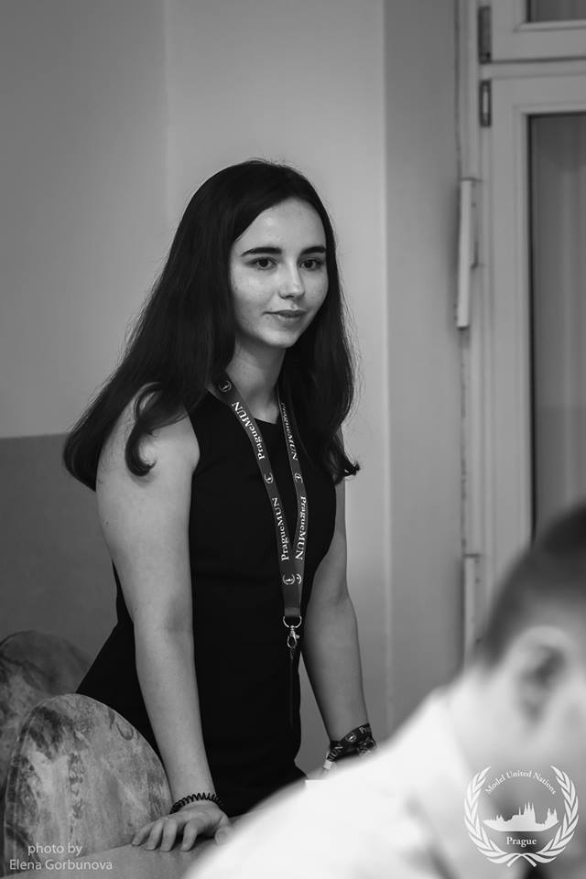

Áine Dolan

law student

I am a Senior who majors in Law and French who has worked in both the American and Irish legal systems. I have experience in corporate law and plaintiff litigation.

## Contact details

|  |  |
| --- | --- |
| Hollybrook,  Ballymaleel,  Letterkenny,  Co. Donegal | W413D  College Park,  Campus Residences DAC, Ballymun Road, Dublin 9 |

**T** 083 8022214

**E** [ainemeabhdolan@gmail.com](mailto:ainemeabhdolan@gmail.com)

[aine.dolan27@mail.dcu.ie](mailto:aine.dolan27@mail.dcu.ie)

[LinkedIn Profile](https://www.linkedin.com/in/áine-dolan-4b88b1107)

#### hOLMES O’mALLEY SEXTON, LIMERICK

##### INTERN in the plaintiff litigation and material damages departments; JULY 2018

* maintaining case files
* shadowing solicitors during court
* attending meetings with clients

#### LIDL IRELAND HEADQUARTERS, TALLAGHT

##### PRUCHASHING ADMINISTRATOR; JUNE 2018

* analyzing contracts in multiple languages including French, Italian, German, Hungarian, Polish, Portuguese, and Swedish
* maintaining a database of all contracts for Lidl Ireland
* printing and getting contracts signed by executives
* managing the post for the purchasing department

**Recruitment Plus, Dublin**

Temporary Receptionist; May – August 2017

* providing secretarial support for clients; managing phone lines, tills, and websites
* being front of house for clients; welcoming guests, answering queries, maintaining security logs, taking deliveries

**PRAMERICA SYSTEMS IRELAND LTD, LETTERKENNY**

INTERN; JUNE-SEPTEMBER

Technology and Vendor Contract Team

* Analyzed contracts for potential liability
* Produced risk assessment memos

Legal and Research Analysis

* Reviewed a legal question in all 50 states of America and its territories
* Reviewed power of attorney applications
* Researched new and emerging areas of law in the U.S.A.

Corporate Governance

* Maintaining the global entity management system
* Reviewing records of company documents
* Reviewing positions within subsidiaries

### Education

### **Sciences po lyon, France**

### **Certificate of Political science Studies 2017 – 2018**

|  |  |  |  |
| --- | --- | --- | --- |
| Through French |  | Through English |  |
| French Language and Methodology | 70 | American Exceptionalism in Health Care Policy and Politics | 65 |
| French Constitutional Methodology | 60 | E.U. Neighborhood Politics | 70 |
| International Commercial Law | 55 | The U.S. and the U.K. Special Relationship | 75 |
| French Constitutional Law | 50 | Strategy and Decision Making | 60 |
| American Constitutional Law | 60 | American Federalism viewed from the States | 65 |
| History of France from 1940 to present day | 50 |  |  |
| Jurisprudence | 80 |  |  |

#### DUBLIN CITY UNIVERSITY, republic of Ireland

#### LAW AND FRENCH 2015-2019

|  |  |
| --- | --- |
| Year 1 | 2nd Class Honours Grade 1 |
| Law of Torts | 64 |
| Irish Legal System | 63 |
| Constitutional Law | 65 |
| French Language 3 | 60 |
| Introduction to Linguistics | 47 |
| Legal Research and Methods | 62 |
| Advanced Torts | 63 |
| French Language 4 | 65 |
| French Language and Literature | 77 |
| Year 2 | 2nd Class Honours Grade 1 |
| Law of Contract | 66 |
| European Union Law | 57 |
| Criminal Law | 43 |
| Advanced Criminal Law | 71 |
| French Language Intermediate | 62 |
| French Translation Practice | 60 |
| French Literature and Film | 68 |
| Advanced Contract Law | 52 |
| Advanced European Union Law | 62 |
| French Fantasy Literature | 53 |
| French Language and Society | 60 |
| French Language 5 | 62 |

### **Leaving Certificate 2015**

|  |  |  |
| --- | --- | --- |
| Irish | B2 | Higher level |
| French | B2 | Higher level |
| Biology | B2 | Higher level |
| History | B3 | Higher level |
| English | B3 | Higher level |
| Accounting | B3 | Higher level |
| Mathematics | C3 | Higher level |

### COMMUNICATION

Received an honorary mention at the Prague MUN 2018

Placed second in the Aoife King DCU Moot trial 2016

Place second in the DCU Criminal Law Mock Court 2016

Grades 1- 9 from the Leinster School of Music & Drama

### LEADERSHIP

S.U. representative for the Joint Honors Program 2015 –2017

Mentor in Rathdown Boarding School 2015

Captain for Loreto Letterkenny Camogie Senior Team 2014

Hobbies

Debate, horse riding, surfing, skiing, Irish language studies, theatre