Adam Keane

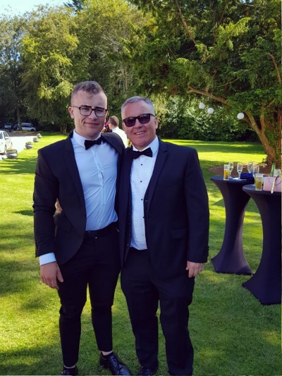

57 Wellpark Grove | Galway | +353830620903 | adamjohnkeane@gmail.com

# Objective

I'm applying for a summer internship at your business. I am a passionate self-motivated individual with an eagerness to learn and I am confident I would be a strong addition to your team. I would appreciate a job interview at your earliest convenience.

# Skills & Abilities

* ● Advanced Level of French (**CEFRL)**
* ● Proficient in Microsoft Excel
* ● Advanced IT Skills
* ● Basic Coding ability

# Experience

## Projectionist, Omniplex Cinema Waterford Current

## *Waterford*

I currently work part time in my local cinema during the college term. I have a huge interest in film, and couple that with the experience and skills earned through this job, it has been a very valuable experience for me.

# Education

**National University of Ireland Galway**

I am currently in my third year of studying corporate law in NUIG. I find this course challenging but also very rewarding. I averaged a 2:1 in first and second year and am on course to get a first this year. My favourite classes to date have been Contract Law, Macro Economics and Global Marketing. After completing my Undergraduate degree, I hope to do a master’s in business administration.

# Extra-Curricular and Hobbies

**Irish Cancer Society**

I have been a committee member of my universities branch of the Irish Cancer Society for a little over a year and I am immensely proud of what we have achieved in that time. Last year we raised thousands putting on an event called ‘Relay for Life’. This was an overnight fundraising event in which cancer survivors were invited to speak and share their stories. It was a massive success and on the strength of this my fellow committee members and I are organizing a charity boxing event in March.