**Andrew Fenton**

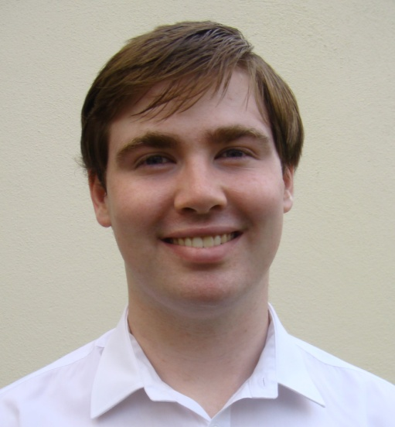**Curriculum Vitae**  
 5 Park Avenue,

Grange Road,

Rathfarnham,

Dublin 16,

Ireland

087 7461126

email: [fentonan@tcd.ie](mailto:fentonan@tcd.ie)

Linkedin profile: https://ie.linkedin.com/in/andrew-fenton-7a16b098

I am a 22 year old recent graduate of European Studies, with a major in Russian language and minor in French language from Trinity College, Dublin. I graduated with a 2.1 degree. I am hard working, enthusiastic and creative. I am currently studying the Master’s in Common Law in UCD. I am interested in pursuing a career as a commercial law.

**Education**

University College Dublin, 2016 - 2018 – Master’s in Common Law

Property Law, Constitutional Law, Contract Law, EU Law, Tort Law, Criminal Law

Trinity College, Dublin, 2012 – 2016 – European Studies (II.I)

Academic record in European Studies: II-I in first year, second year, third year and final year.

Year studying abroad in Gorky Literary Institute, Moscow 2014 – 2015 – 2.1

Leaving Certificate – 590/600 points. Blackrock College, Co. Dublin.

I was awarded a special award in contribution to academics in my school in both 2011 and 2012. I achieved the highest results in my year in both history and religion in 2011 and 2012.

**Experience**

Work in Current Affairs

* DU Amnesty, Trinity College Amnesty International Society 2012-2015

Fresh Amnesty Voices, 2013-2014

I was the leader of the Fresh Amnesty Voices group within the Amnesty International society in Trinity College. I also participated in other areas of the society as an ordinary committee member. I was a member of the committee, liaised with the National Amnesty Youth Group and organised speakers for the society.

* I was the politics officer of the Europa society.
* I worked with the Irish Club in Moscow. As a Russian speaker I attended Irish Club events with flyers and leaflets to explain the events to Russian people. I was also involved with fundraising.
* I worked as a runner in RTE during the General Election of 2016. My duties involved dealing with the requirements of guests

Work in Education

* I was elected by my peers to be the class representative for the Stage 1 MCL class and as Student’s Union Representative for all students studying a master’s in the Sutherland School of Law.
* In 2014-2015 I worked as an English teacher in Moscow, teaching groups of adults and children at Synergy University.
* I was a self employed English teacher in Moscow, teaching children in the greater Moscow area from 2014-2015.
* I was a group leader at I-camp with Synergy University, a series of camps organised to promote the university to teenage students considering studying Business and English.
* Assistant at Euro Languages College, a summer camp for Irish teenagers learning French in 2011.
* I gave grinds from 2012 to 2016 to leaving certificate students of French.

Work in Customer Service

* I am currently working as a food and beverage assistant in the Gibson Hotel.
* During the summer of 2013 I worked in the Auberge de Jeunesse de Namur, the largest youth hostel in the city of Namur, Belgium. My duties included working as a waiter, performing administrative duties and bar work.
* I worked as volunteer on an Apare work camp in La Bastidonne in the south of France, where 13 students from different places in Europe worked together to build a pathway for the people of the town.
* I worked as a sales assistant in the Oxfam shop in Rathfarnham while I was in school

**Personal interests and achievements**

Sports – hill-walking, cycling, scuba-diving (PADI certified), swimming, basketball and rock climbing

Music – I play the piano (grade 7 standard) and trumpet (grade 5 standard)

I play the trumpet with the Rathfarnham Concert Band

Distinction in grade 5 music theory, awarded by ABRSM

Acting – member of Ann Kavanagh’s Young People’s Theatre and Trinity College Players Society – honours in grade 6 speech and drama, awarded by the Royal Irish Academy of Music and Drama

Debating – I was a member of my school debating team and was awarded the Gold Medal for debating in transition year.

**Skills profile**

Language Skills – Native English speaker

Professional working proficiency in **Russian, French and Irish**

Confident and talented public speaker - honours in grade 8 public speaking, awarded by the Guildhall School of Music and Drama

Proficient in IT – awarded ECDL award

Excellent essay writing and critical thinking skills – I was awarded a first class honours mark in many essays which I wrote in Trinity College

* An investigation into the Stalinist pursuit of homosexuals in the 1930s – 71%
* Why are institutions in African states failing to deliver development? – 70%

**Referees**: Sarah Smyth – Head of Department of Russian and Slavonic Studies at Trinity College Dublin – [Sarah.Smyth@tcd.ie](mailto:Sarah.Smyth@tcd.ie); phone number: 35318961819

Youth Hostel Namur – phone number: +32 (0)81 22 36 88;