**Andrew Fenton**

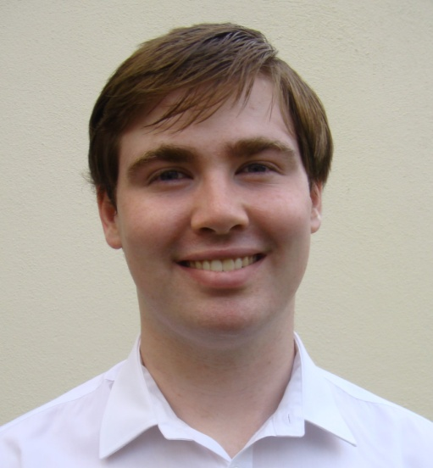**Curriculum Vitae**  
 5 Park Avenue,

Grange Road,

Rathfarnham,

Dublin 16,

Ireland

087 7461126

email: [fentonan@tcd.ie](mailto:fentonan@tcd.ie)

I am recent graduate of European Studies with French and Russian from Trinity College, Dublin. I graduated with a 2.1 degree. I am hard working, enthusiastic and creative. I am currently studying the Master’s in Common Law in UCD. I am interested in pursuing a career as a solicitor.

**Education**

University College Dublin, 2016 - 2018 – Master’s in Common Law

Property Law, Constitutional Law, Contract Law, EU Law, Tort Law, Criminal Law

Trinity College, Dublin, 2012 – 2016 – European Studies (II.I)

Academic record in European Studies: II-I in first year, second year, third year and final year.

Year studying abroad in Gorky Literary Institute, Moscow 2014 – 2015 – 2.1

Leaving Certificate – 590/600 points. Blackrock College, Co. Dublin.

I was awarded a special award in contribution to academics in my school in both 2011 and 2012. I achieved the highest results in my year in both history and religion in 2011 and 2012.

**Experience**

Work in Current Affairs

* DU Amnesty, Trinity College Amnesty International Society 2012-2015

Fresh Amnesty Voices, 2013-2014

I was the leader of the Fresh Amnesty Voices group within the Amnesty International society in Trinity College. I also participated in other areas of the society as an ordinary committee member. I was a member of the committee, liaised with the National Amnesty Youth Group and organised speakers for the society.

* I was the politics officer of the Europa society.
* I worked with the Irish Club in Moscow. As a Russian speaker I attended Irish Club events with flyers and leaflets to explain the events to Russian people. I was also involved with fundraising.
* I worked as a runner in RTE during the General Election of 2016. My duties involved dealing with the requirements of guests

Work in Education

* I was elected by my peers to be the class representative for the Stage 1 MCL class and as Student’s Union Representative for all students studying a master’s in the Sutherland School of Law.
* In 2014-2015 I worked as an English teacher in Moscow, teaching groups of adults and children at Synergy University.
* I was a self employed English teacher in Moscow, teaching children in the greater Moscow area from 2014-2015.
* I was a group leader at I-camp with Synergy University, a series of camps organised to promote the university to teenage students considering studying Business and English.
* Assistant at Euro Languages College, a summer camp for Irish teenagers learning French in 2011.
* I gave grinds from 2012 to 2016 to leaving certificate students of French.

Work in Customer Service

* From October to December 2016 I worked with Prop Me Up, as an elf, at Christmas grottos in shopping centres around Dublin.
* During the summer of 2013 I worked in the Auberge de Jeunesse de Namur, the largest youth hostel in the city of Namur, Belgium. My duties included working as a waiter, performing administrative duties and bar work.
* I worked as volunteer on an Apare work camp in La Bastidonne in the south of France, where 13 students from different places in Europe worked together to build a pathway for the people of the town.
* I worked as a sales assistant in the Oxfam shop in Rathfarnham while I was in school

**Personal interests and achievements**

Sports – hill-walking, cycling, scuba-diving (PADI certified), swimming, basketball and rock climbing

Music – I play the piano (grade 7 standard) and trumpet (grade 5 standard)

I play the trumpet with the Rathfarnham Concert Band

Distinction in grade 5 music theory, awarded by ABRSM

Acting – member of Ann Kavanagh’s Young People’s Theatre and Trinity College Players Society – honours in grade 6 speech and drama, awarded by the Royal Irish Academy of Music and Drama

Debating – I was a member of my school debating team and was awarded the Gold Medal for debating in transition year.

**Skills profile**

Language Skills – Native English speaker

Professional working proficiency in **Russian, French and Irish**

Confident and talented public speaker - honours in grade 8 public speaking, awarded by the Guildhall School of Music and Drama

Proficient in IT – awarded ECDL Start

Academic and Professional **Referees** available upon request

University subjects and results to date:

**European Studies –**

1st year results – 2:1

Introduction to History of Ideas 55% 2:2

European History: 1500-1700, Power and Belief 59% 2:2

Introduction to Social Sciences 56% 2:2

Russian Language 58% 2:2

Russian Oral 67% 2:1

French Language 62% 2:1

French Oral and Aural 73% 1:1

Russian Area Studies 67% 2:1

2nd year results – 2:1

Russian Language 62% 2:1

Russian Oral 71% 1:1

French Language 54% 2:2

European History: 1250-1515, Religion and Culture 62% 2:1

European History: 1700-1815, Culture and Politics 62% 2:1

Making of Modernity: 1750-1850 66% 2:1

Russian Area Studies 77% 1:1

Ideas into Politics 65% 2:1

3rd year results – 2:1

Spent in the Gorky Literary Institute, Moscow, results are were converted by Department of Russian and Slavonic Studies

All subjects, with the exception of French Language, were carried out entirely through Russian

French Language 1:1

Philosophy 1:1

European History 1:1

19th and 20th Century Russian History 1:1

Classical Civilisations 1:1

Academic essays in Russian 62% 2:1

Russian Language 2:1 79.4% in Level 2, Test of Russian as a Foreign Language (proof of professional working proficiency in Russian Language)

4th year results – 2:1

Democracy and Development 62% 2:1

Stalinism and Society in Eastern Europe 68% 2:1

Modernity and Society 65% 2:1

Russian oral proficiency and writing skills 64% 2:1

Russian receptive skills 62% 2:1

Contemporary Russian Society 68% 2:1

French Language 60% 2:1

**Master’s in Common Law –**

1st year subjects

Property Law

Tort Law

Key Issues in Irish Public Law

EU Law

Criminal Law

Contract Law