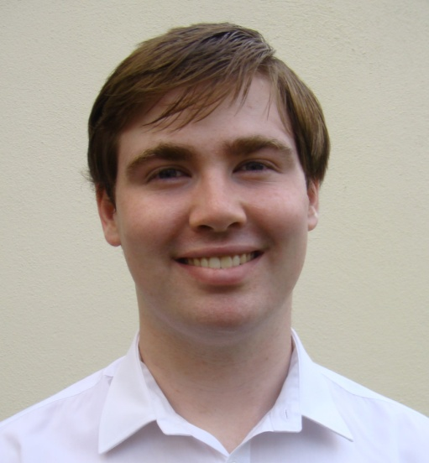**Andrew Fenton**

5 Park Avenue,

Grange Road,

Rathfarnham,

Dublin 16,

Ireland

087 7461126  
Linkedin profile: www.linkedin.com/in/andrewfentonUCDLaw

Email: [fentonan@tcd.ie](mailto:fentonan@tcd.ie)

**Education**

**University College Dublin**, 2016 - 2018 – Masters in Common Law

First year GPA: 3.8 (1.1)

Class representative; Student’s Union representative for all postgraduate law students in UCD

**Trinity College, Dublin**, 2012 – 2016 – European Studies with French and Russian (2.1)

Russian; French; History; Political Science; History of Ideas; Sociology

**Gorky Literary Institute**, Moscow 2014-15: third year spent studying Moscow (2.1)

Russian language, European history, modern Russian history, philosophy and classics, all studied through Russian.

Learning Russian, living in Moscow, and studying the culture, history and politics of Russia brought a different and balancing dimension to the European Studies programme as a whole.

**Leaving Certificate** – Blackrock College; 590 points.

I was awarded a special award for academics in my school in both 5th and 6th year as I placed in the top 5 students in my year. I achieved the highest results in my year in both history and religion in 5th and 6th year.

**Experience**

**Work in Legal and Current Affairs**

* **Beauchamps** Summer Internship Programme, July-Aug 2017. I worked as an intern in the corporate department. I carried out research, drafted legal documents and assisted on a merger.
* **Matheson** Summer Internship Programme, May-June 2017. I worked in the Employment, Pensions and Benefits department. My duties included carrying out research, drafting letters for clients and briefs for court.
* Volunteer at **Society of Legal Scholar’s** annual conference in UCD, Sep 2017.
* DU Amnesty, Trinity College **Amnesty International** Society 2012-2015

Fresh Amnesty Voices, 2013-2014

I was the leader of the Fresh Amnesty Voices group within the Amnesty International Society in Trinity College. I also participated in other areas of the society as an ordinary committee member.

* I was the politics officer of the **Europa society** in Trinity College Dublin.
* I worked as a runner in **RTE** during the General Election of 2016. My duties involved dealing with the requirements of guests and assisting the stage manager.

**Work in Education**

* I was elected by my peers to be the **class representative** for the first year MCL class and as Student’s Union Representative for all postgraduate students in the Sutherland School of Law. I was re-elected for this role in my second year.
* In 2014-2015 I worked as an **English teacher** in Moscow, teaching groups of adults and children in Synergy University, Moscow.
* I was a **group leader** at I-camp with Synergy University, a series of camps organised by the university for school students considering studying in the university.

**Work in Customer Service**

* I currently work part-time with Prop Me Up as an **event assistant**. In winter 2016 I joined Prop Me Up and worked as an elf at Christmas grottos in shopping centres around Dublin. As a result of my enthusiasm and commitment to the job I was awarded a Christmas bonus, given to the best employees. I now work with Prop Me Up on a part-time basis in a range of roles, but particularly in promotional roles.
* In summer 2016 I worked in the Hemi bar of the **Gibson Hotel**, Dublin. My duties included serving food and drinks to customers, ensuring customer satisfaction at all times, working as part of a team in a fast paced environment and carrying out all duties according to the Hotel's 4 star standards.
* In the summer of 2013 I worked in the Auberge de Jeunesse de Namur, the largest **youth hostel** in the city of Namur, Belgium. My duties included working as a waiter, performing administrative duties and bar work.
* In the summer of 2014 worked as volunteer on an **APARE work camp** in La Bastidonne in the south of France, where 14 students from Africa, Asia and Europe worked together to restore a traditional cobblestone pathway.

**Personal interests, skills and achievements**

**Languages** - Native English speaker; professional working proficiency in Russian, French and Irish

### Member of the UCD team for the Willem C. Vis International Commercial Arbitration Moot 2018 – consists of submitting written memoranda prior to the moot and delivering oral arguments in Vienna

**Sports** – Cycling, scuba-diving (PADI certified) and swimming

I am a member of the UCD cycling club. I regularly cycle around Ireland. I cycled along the Canal du Midi in France and have cycled from Passau, Germany to Budapest, Hungary.

**Music** – I play the piano (grade 8 Standard) and the trumpet

I play the trumpet with the Rathfarnham Concert Band, every year we play in local concerts such as Christmas events in Churches. We also play in the National Concert Hall every November.

Distinction in grade 5 music theory, awarded by ABRSM

**Acting** – member of Ann Kavanagh’s Young People’s Theatre and Trinity College Players Society – honours in grade 8 speech and drama, awarded by the Royal Irish Academy of Music and Drama. I am currently a member of UCD’s Drama Society.

**Travelling** – during my year abroad in Moscow I travelled along the trans-Mongolian railway, visiting Siberia, Mongolia and China.

**Confident at Public Speaking** – honours in grade 8 public speaking, awarded by the Guildhall School of Music and Drama