**Andrew Synnott - Curriculum Vitae**

**September 2018**

**1. Personal Details**

Address 10 Dunboy, Brighton Road, Foxrock, Dublin 18, Ireland.

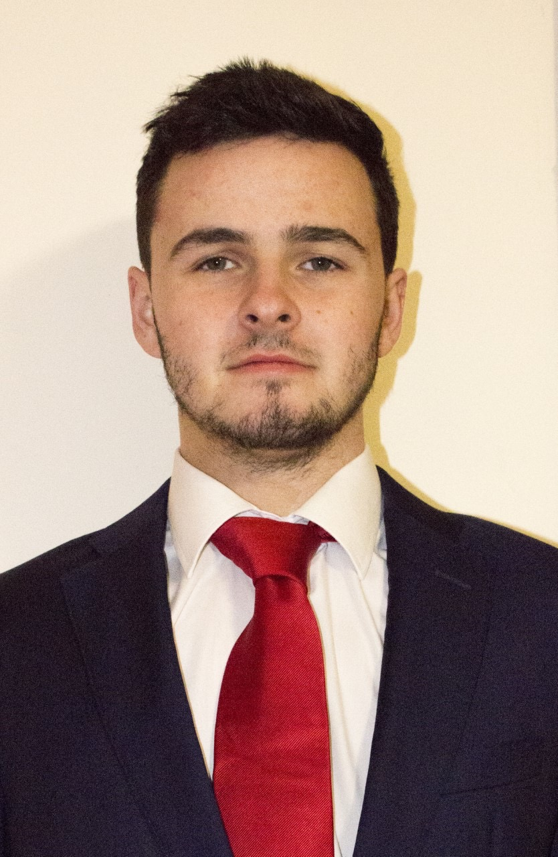

Telephone +353 87 993 8707 (mobile)

Email [andrew100synnott@hotmail.com](mailto:andrew100synnott@hotmail.com)

Date of Birth 17/04/1996

**2. Education**

**Law (LL.B) Dublin Institute of Technology**

2016/17 Final year, LL.B Degree, DIT (Examination Result 3.72 grade point

Average i.e, Second Class Honours, Grade 1).

2015/16 Second Year, LL.B Degree, DIT (Examination Results 3.46 grade

point average i.e, Second Class Honours, Grade 1).

2014/15 First Year, LL.B Degree, DIT (Examination Results 3.46 grade

point average i.e, Second Class Honours, Grade 1).

**School**

2008/09 – 2013/14 Secondary School – Blackrock College, Blackrock, Co. Dublin

Leaving Certificate Results 475 points (out of a maximum of 600).

2000/01 – 2007/08 Primary School – St Brigid’s BNS, Cabinteely, Dublin 18.

**Work Experience**

**3. Work and Other Experience**

Sep 2017 – Jan 2018 Legal Intern, Eversheds Sutherland in the Litigation Department. My main

focus in this internship was the enforcement of mortgages.

June 2017 – Aug 2017 Summer Intern, Baily Homan Smyth McVeigh Solicitors, Litigation

Department, with focus in Insolvency.

Aug 2016 – May 2017 Legal Intern, Synnott Lawline Solicitors, Personal Injury, Family and

Employment Department.

June 2015 – May 2016 Sales Assistant, Centra Dalkey. Responsible for ensuring adequate levels

of stock, managing the tills, training new staff and maintaining cleanliness

on the stop floor.

**Other Experience**

2016 – 2017 100 Minds Participant. This is an initiative which challenges students to raise

€1,000 for Temple Street Children’s Hospital. I organised numerous events,

such as bag packing and a comedy night in the Laughter Lounge. I raised a

total of €1,536.

2015 – 2016 Second Year Representative, DIT Law Society.

2015 – 2016 Mentor, DIT Law Society

2012 Head of Sales, Blackrock College Radio. Project in aid of St. Vincent De

Paul. Responsible for selling advertisement slots to companies around Ireland

2012 Volunteer with Goal/Aidlink during the annual St. Patrick’s Day badge

appeal.

**4. Skills, Interests, Hobbies**

* Competent level of IT literacy from completing ECDL course, including knowledge in

Microsoft Word, Excel and PowerPoint, with a typing speed of 105 words per minute.

* Full Irish driving license.
* Golf, Football, Ultimate Frisbee, gym
* Bronze Gaisce Award