*1*

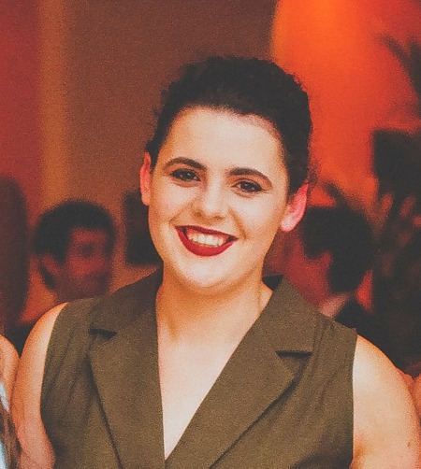

CLAIRE O’REILLY C V

**ADDRESS:** *50 Strandville Avenue*

*North Strand,*

*Dublin, D3*

**Phone:** *083 443 6656*

**EMAIL:** *sheilajlcassidy@gmail.com*

**DIGITAL MARKETING MANAGER | GOOGLE**

*December 2012 - Present*

Liaising closely with internal design and development teams, I was responsible for brainstorming, managing and implementing SEO and PPC campaigns within the R&D / Inspiration team. Working at the forefront of the marketing team I have been instrumental in driving recognition for breakthrough projects. Through insight and analysis of Google Analytics I have increased ROI by 12% and CTRs by 18%.

**DIGITAL MARKETING ASSISTANT | AMAZON**

*January 2009 – November 2012*

Supporting an established Digital Marketing team of 20 my responsibilities included the setup and management of digital marketing campaigns; generating reports and insight for the wider marketing team; brainstorming new marketing concepts and mentoring junior members of the team. My key focus was centred on SEO, PPC, Google Analytics and the UI Design of Landing Zones.

**EMAIL CAMPAIGN ASSISTANT | AOL**

*August 2006 – December 2008*

After graduating from university I joined AOL as part of a graduate programme within their Digital Marketing department. Specialising in Email management and distribution I held responsibility for the design, development and distribution of 120m B2C emails per year. Geared towards retention and subscription management programmes I had to create and manage engaging email campaigns as part of a team.

**EXPERIENCE**

*MAILCHIMP*

*HTML / CSS*

*PPC / SEO*

**Leaving Certificate:**

*545 points*

*7 Honours Subjects Taken Through Irish*

**BCL (International) 2H1**

*University College, Cork, Ireland*

*University of Copenhagen*

**Law LLM- Grade Pending**

*University of Edinburgh*

*First Year and Final Year Class Representative for Law International*

*Law Student Council Member 2014/2015; 2017/2018*

*Recording Sec of the 86th Session of UCC Law Society*

*UCC Peer Link Support Leader*

*Competed internationally with the UCC Trampoline and Tumble Club*

*Involved in the organisation of Law Society events, including Take Me Out and Law Dinner*

**Referee**

*Dr Gillian Black,*

*Senior Lecturer,*

*University of Edinburgh*

*gillian.black@ed.ac.uk*

**Non-Academic Activities:**

**Academic Activities**

*2F1 1 South Oxford Street, Edinburgh, EH89QF*

**DOB: 21/03/1996**

**MOBILE:** *+44 7576181611*

**EMAIL:**claire.m.a.oreilly@gmail.com

I am an LLM student at the University of Edinburgh. I have a second class honours degree in Law (International) from University College Cork. I spent the third year of my degree studying at the University of Copenhagen. I am an avid public speaker with a broad range of interests both academically and non-academically. The experiences detailed below have given me a skillset and a work ethic which make me highly suitable to a career in law.

**Areas of Interest in law**:

* Litigation
* Dispute Resolution
* Family Law- First in class in Family Relationships
* International Criminal Law- Full marks awarded in exam
* Criminal Law- Dissertation in Sexual Offending and the Law

**Skills:**

* Public speaking and debating
* Communication skills
* Administrative skills
* Fluent Irish speaker: completed my leaving certificate through Irish.
* Competent French and Spanish speaker
* Time Management

**Work Experience to date**:

* Currently a Sales Assistant at Dr Marten Edinburgh
* Intern at Ronan Enright Solicitors Summer 2018
* Intern at Pope’s Quay Legal Centre June 2018
* Waitress at The Wine Tavern Oct 2015- July 2016
* Waitress at Idaho Gelato May 2016- August 2016
* Waitress at Jacques Restaurant May 2015- August 2015
* Volunteer at Arc House Cancer Support House Fundraising Office June 2013- September 2013

**Hobbies:**

* Running- Completed EDP Lisboa 2018
* Film- Particular interest in minority representation in film
* Music- Violin ABRSM Grade 6
* Public Speaking- Recording Secretary of the UCC Law Society, debating at UCC Law Society house meetings, shortlisted for Annual Gala Moot 2018.

on

**Referees:**

**ADDRESS**

**INTRODUCTION**