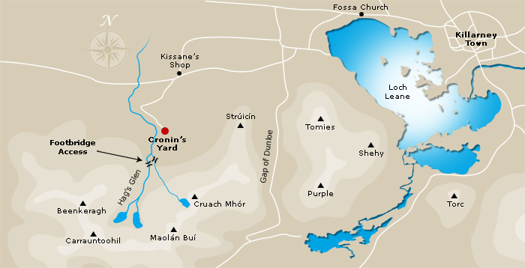
Directions to Cronin's Yard
From Killarney: Take the N72 (Ring of Kerry road) towards Killorglin. After Fossa Village, turn left for the Gap of Dunloe. Continue on this road for approximately 8km until you come to Kissane's Shop and Maxol Service Station. Go over a small bridge and take the next left (signposted for Cronin’s Yard and Tea Room, Carrauntoohil). Proceed to the end of this road, approximately 3km to Cronin's Yard.
Sat Nav Coordinates: Lat: 52° 1'35.74"N / Long: 9°41'46.41"W
Grid reference: IV 837 873

