### Curriculum Vitae

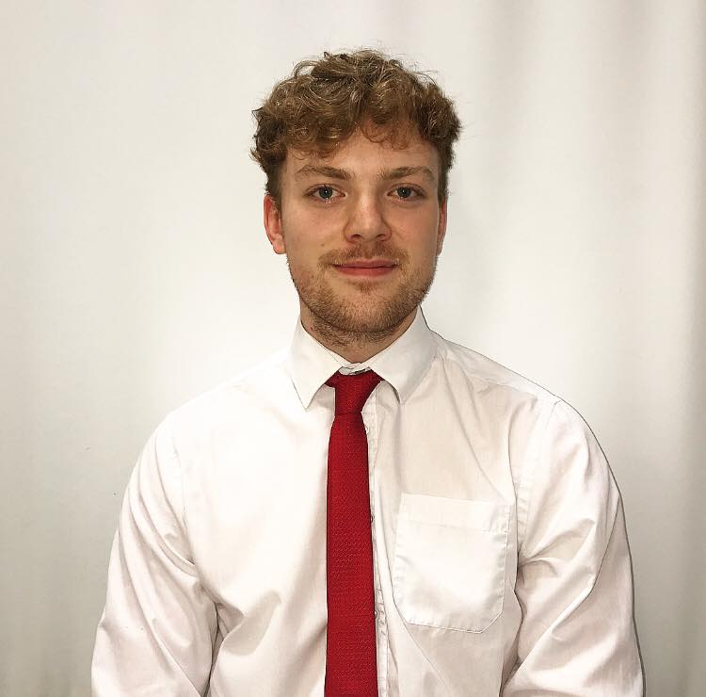

**Eddie O’Rourke**

E-mail: [116433226@umail.ucc.ie](mailto:116433226@umail.ucc.ie) / eddieorourke@yahoo.co.uk

Address: Ballybrack, Firies, Killarney, Co. Kerry.

D.O.B: 16th June 1997. Telephone number: 085 2423931

### Education

2016-2019 - *University College Cork* – BCL Law, final year.

**Exam results:**

* 1st year: Overall Grade **2.1** including 63% in Law of Torts and 61% in Contract Law.
* 2nd year: Overall Grade **2.1** including 70% in Law of Evidence II, 68% in Revenue Law and 64% in Law of Property II

**2nd year Group Project:** The LW2262 ‘Clinical Legal Skills – Group Work and Presentation’ module provided an opportunity for me to experience a group dynamic that I, as far as in an educational or academic sense, had not been a part of before. It was the first time I had been apart of a wider group of people where we had one main goal, but also many sub-responsibilities and duties. Our goal was to produce a competent presentation on socio-economic rights and whether we felt they should be explicitly included in the Irish Constitution. We needed to compile a knowledgeable body of work but also to broadcast that work clearly and effectively in an oral presentation.

Giving an oral presentation, on a difficult topic, within a time constraint, while being assessed was daunting. Yet, I feel as if my communication, teamwork and interpersonal skills were greatly developed as a result of this project as I was working with people previously unknown to me. Working in a group, too, proved a fruitful experience as through our shared knowledge I believe we produced a satisfactory well-rounded presentation.

* 3rd year (final year): no results to show as of yet.

**3rd year subjects:** Law of Equity, Law of Employment, Law of Privacy and Data Protection, Medical Law, Sports Law, Moot Court, Contemporary Issues in Corporate Law, Jurisprudence, Income Tax Law

**Secondary Education:** 2010-2016, Intermediate School, Killorglin, Co. Kerry.

Leaving Certificate: **540**/600 CAO points (Top 5% nationwide).

### Recent Employment

J.M Reidy’s - bar, restaurant and cafe / Social15 Nightclub, Killarney, Co. Kerry – 2017-18 – Floor Staff

* I was trusted to offer a competent service and be friendly and polite in serving customers, often customers of different nationalities, as Killarney is a very touristic town.

TK Maxx, Main Street Killarney – May – June 2018 – General Associate

* As not all shifts were timetabled, I was often called into work on days off, etc. As such I learned how to adapt to an unpredictable schedule and to be able to work with short notice.
* I gained experience of working for a global company, and the responsibility of upholding the name of such a well-known company.

Healy Crowley Ahern Solicitors – Legal Intern, July – August 2018

I spent 8 weeks working in a busy legal firm with offices in both Killorglin and Caherciveen, County Kerry. While a fast paced and busy solicitors’ office, I was able to gain invaluable one to one experience with the principal of the firm, Mr. Colm Kelly.

* I became introduced to the legal software of “Documatics” and progressively became more adept and competent on the system.
* I became extremely familiar with the drafting of wills and their structure. I was tasked with scheduling and reviewing over 900 wills but also involved in meeting clients regarding wills.
* I worked closely with clients’ mortgages, namely reviewing client files and confirming whether our undertakings to the bank had been discharged. This involved reviewing client files and writing to the bank for confirmation of discharge.
* Similarly, I was tasked with preparing clients’ certificate of title folders, which would subsequently be sent to the bank. As such, I became familiar with all the relevant property documents involved in the mortgage procedure.
* A firm mainly concerned with property law, conveyancing and transfers, I became very familiar with the Land Direct website and used the site almost daily.
* I too, dealt with unregistered property and became familiar with deeds and conveyancing. One project involved me scheduling all of the title deeds we had in the office.
* Some days I spent solely shadowing the principal solicitor and attending all in office and out of office meetings alongside him. He would explain to me the details of the meetings and I would subsequently take notes in the meetings. The types of meetings and the subject matter of the meetings varied from client to client and as a result I got invaluable exposure to the typical working day of a busy solicitor.
* Some meetings were with people connected to the running of the firm such as meetings with our tax consultant and accountant, so I also got to see that side of the law firm.
* I was sometimes tasked with drafting letters both to banks and also clients of ours. As such I became familiar with the structure, wording and style of legal correspondence.
* Similarly, I would write up attendance notes following a meeting or phone call with a client.
* The firm also comprised of a criminal solicitor, Mr Brendan Ahern. I would often attend court alongside Brendan. We would meet in the morning before court commenced and he would explain to me his upcoming cases that day. I would then watch the court in session and take notes of cases, particularly our own cases which I knew the ins and outs of. Even still I would be watching the full day of court and would be exposed to all different types of cases with their own individual facts and circumstances and as such became acquainted with court procedure, the language of the court, as well as the differing types of cases.
* Often trusted to answer phone calls to the firm, as well as make phone calls regarding various queries etc.
* Greatly improved my Microsoft Excel and Word proficiency, as well as my typing.
* Completed one task involving clients’ shares where I had to make phone calls and inquiries as to share prices and accordingly update our clients’ shares database.

**Interests and achievements**

* I have a keen interest in sport and fitness: I have participated in individual sports, as well as team sports. While in secondary school I participated in track and field, and throughout my childhood and teenage years I played Gaelic football, basketball and soccer.
* In my first year of BCL at University College Cork I completed a six-week course called “bystander intervention”. The module was set up with the aim of improving our social skills and to encourage us how to intervene correctly in problematic social situations. I found the module a valuable experience and have been able to implement what I have learned into my everyday life. The module ranged from issues of sexual misconduct to, more broadly, issues such as personal assertiveness and social responsibility.
* I have a great interest in modern history, particularly Irish and European history, although I decided to complete my leaving cert history project on a topic of American history.
* I was selected as one of the organising members of my school’s Debs Ball. I had to use my organisational skills and teamworking skills in coming together with fellow class mates to successfully organise a venue, transport and a pre-debs meeting point.
* Whilst working with TK Maxx over the summer of 2018 we had one day of fund raising for Enable Ireland. I really enjoyed the experience and knowing that what I was doing was benefitting a good cause so as such, the following September I joined the UCC Saint Vincent de Paul Society.
* I have mentioned playing sports, but I was also asked to coach one of my local basketball clubs’ underage teams. I enjoyed the experience immensely, working with the young children helping them develop their skills but also to enjoy the game.
* I have completed my driving test and am a fully licensed driver.
* I have various sporting achievements, both individual accolades and team achievements.
* In secondary school I received awards in two different years for perfect attendance.
* I feel, overall, that I have a good work ethic and a determination to succeed shown by strong academic record, as well as a willingness to work displayed through the various jobs I have had.

### Referees

Colm Kelly James O’Mahony

Principal Solicitor Vice-principal / teacher

Healy Crowley Ahern Solicitors Intermediate School Killorglin

Iveragh Road, Killorglin Iveragh Road, Killorglin

[ckelly@hcalaw.ie](mailto:ckelly@hcalaw.ie) iskadmins@eircom.net

[www.hcalaw.ie](http://www.hcalaw.ie) [www.isk.ie](http://www.isk.ie)

066 9761295 066 9761246

**I would like to take this opportunity to thank you for taking the time to read my curriculum vitae.**

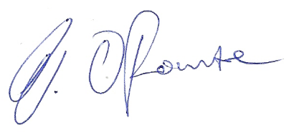

**Eddie O’Rourke**