**Emma Sweeney**

5 Auburn Heights, Athlone, Co.Westmeath, Ireland/ [Emma.sweeney@ucdconnect.ie](mailto:Emma.sweeney@ucdconnect.ie/) / 0857572710

**Education**

**Leaving Certificate Results:**

Total Leaving Certificate points: 530

History – Higher A1, Religion- Higher A2, Geography-Higher B1, Maths- Higher B3, Biology Higher B2, French- Higher B3

**University Results:**

First Year Results. GPA: 3.67 Second Year Result: 3.37

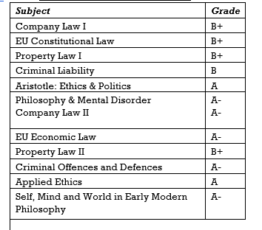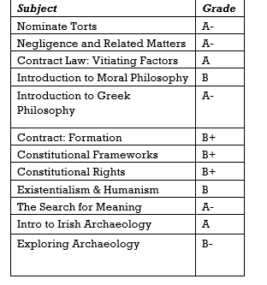

Third Year results:

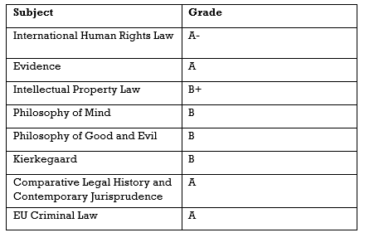

**Volunteer Experience & Achievements.**

* I was ‘Fika Host’ during my Erasmus in Ostgota Nation’s Mjolkbaren Café in Sweden.
* I have been a committee member of the Literary and Historical Society. I acted as Inclusion Officer in 2016 and am presently the Internal Debating Officer.
* I have volunteered with The Simon Community in Athlone.
* I am presently working for my Gold Medal in Gaisce (Irish President’s award) and have completed my Bronze and Silver Awards.
* I was a panel member of the Law Forum Board in UCD in 2015/2016.
* I was selected to take part in the A&L Goodbody Law Start Day 2017.
* I have a Diploma in EU Clinical Law from UCD.

**Work Experience.**

RESIDENTIAL ASSISTANT • UNIVERSITY COLLEGE DUBLIN • AUGUST 2018-JULY 2019

Residential Assistances help develop the community, provide leadership and assist in out of hours aspects of UCD residences. As part of this role I worked in a team to create a safe, inclusive and fun environment in the residence. This role has helped me develop my communication and management skills.

SUMMER INTERN • PRICEWATERHOUSECOOPERS • JUNE 2018-JULY

2018

I worked in the Foreign Direct Investment department of the Firm. My main responsibilities included drafting emails and letters to clients, creating and managing Excel spreadsheets and taking part in client focused team projects. I developed excellent communication and IT skills.

CUSTOMER SERVICE AND ADMINISTRATION • ZUPPLER INTERNATIONAL

• JUNE 2017-OCTOBER 2017

I monitored and managed live and past orders. I was responsible for client phone calls and emails. I assisted with client troubleshooting. My high level of communication skills was invaluable when I assisted clients with their queries and requests. I managed website control panel and carried out website edits. I developed excellent computer skills, including excel skills.

LEGAL SECRETARY • MELLOTTE, O’CARROLL & HOGAN • JUNE 2016-

AUGUST 2016

I drafted legal correspondence to clients and other firms. I managed the office switch board. I assisted with client queries and appointments. I was trained on the database ‘Corebase’. I was responsible for archiving files.