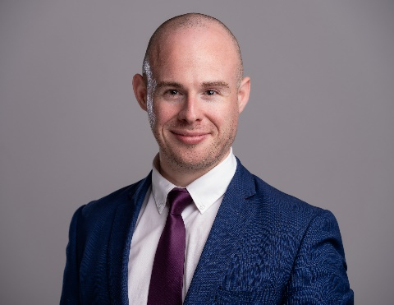**HIGHLIGHTS**

- Experience in Corporate, Data Protection and Litigation

- Client Interaction & working closely with Associates and Partners

- Attention to Detail and Taking Instructions

- Billing hours through Keyhouse

- Legal Writing / Researching

- Time Management / Balancing a Varied Workload

- Microsoft Office - Personable & Energetic

**EDUCATION**

**Law Society of Ireland**

Certificate in Data Protection & GDPR Compliance Nov 2018

FE1 Examinations Oct 2017 – Oct 2018

**Trinity College Dublin**

LL.M (2.1) Sep 2014 – Aug 2015

**Dublin City University**

Bachelor of Economics, Politics & Law (2.1)

Graduated 6th in a class of 29 Sep 2011 – June 2014

**Institute of Commercial Management**

Sports Journalism Jan – April 2011

**The Kings Hospital** (Secondary School) 2003-2009

**EXPERIENCE**

**Wallace Corporate Counsel** *39 Northumberland Road, Ballsbridge, Dublin 4*

***Legal Executive*** August –

⬩ Drafting loan novation agreements, business transfer agreements, deeds of release, share purchase agreements, dispensation Packs and employment contracts;

⬩ Drafting share-for-share exchange documents as part of a corporate reorganisation (incl. board minutes, offer & acceptance letters, and stock transfer forms);

⬩ Compiling completion bibles and drafting internal memos for our knowledge management system;

⬩ Draftingt transaction documents, deliverables and ancillaries as a part of funding rounds;

⬩ Incorporating companies, resigning directors / secretaries on CORE, and filing forms in the CRO; and

⬩ Attending CPD sessions on topics such as Enterprise Ireland investments.

**Philip Lee Solicitors** *7/8 Wilton Terrace, Dublin 2*

***Data Protection – Supporting Department Partners*** Jan – July 2019

⬩ Part of the firm’s 4-person data protection team – responsibilities included ensuring internal GDPR compliance across HR, Accounts etc., producing articles for the website, drafting template data processing agreements and updating the firm’s privacy policy in anticipation of a ‘no deal’ Brexit;

⬩ Advising public bodies on their responsibilities as data controllers / processors, and responding to data subject access requests (DSARs);

⬩ Working closely with an Equity Partner in the preparation of Memorandums of Advice, responding to DSARs and interpretation of GDPR and 1988 and 2003 Data Protection Acts;

⬩ Drafting memos of advice for clients on points such as the new Data Sharing and Governance Act 2019, and the use of CCTV footage in an employee disciplinary procedure; and

⬩ Responsible for producing and circulating the firm’s internal weekly data protection updates.

***Intern – Litigation Department*** May – July 2019

⬩ Compiling Books of Correspondence and Pleadings for briefing Counsel;

⬩ Drafting letters to Counsel and to opposing parties; and

⬩ Attending Mediations, preliminary meetings and client / counsel phone calls.

***Intern – Corporate / Commercial Department*** Jan – May 2019

⬩ Transactional work – Drafting shareholder agreements, service agreements, letters of engagement, board minutes and marking up commercial contracts;

⬩ Conducting red flag due diligence reports, redline comparisons and company secretarial work;

⬩ Attending client meetings and drafting Memorandums of Advice;

⬩ Involved in advising in the sale of an Irish-based solutions provider to a UK company – drafted a reseller agreement, an agency agreement and advised on a disgruntled minority shareholder;

⬩ Involved in preparing a successful tender for a large group of Irish companies. This included estimating the time to complete a high-level due diligence and advising on the companies’ options for corporate restructuring (e.g. the pros and cons of merger by absorption v. merger by acquisition); and

⬩ Advising HPSU Companies and attending tech-start up events to offer free legal advice.

**MLI International Schools** *13 Fitzwilliam Square E, Grand Canal Dock*

***Director of Studies*** June – Sep 2018

⬩ Responsible for a team of 10 teachers & 150 students;

⬩ Established & maintained open communication among staff, with clients and head office;

⬩ Implemented & maintained correct academic procedures, including placement testing, class size & composition, allocation of teachers to appropriate classes, records of work & certificates; and

⬩ Conducted weekly staff reports & payroll for head office.

**Other**

**Tajamar College, Department of English** – ***English Language Instructor*** (Sep 2015 – June 2017);

**McDowell Purcell Solicitors – *Legal Intern*** (Sep 2014 – Nov 2014); and

**J1 Working Visa in Chicago** (May – Sep 2013).