Name Imogen Boles Gray

Address 2 Bellcourt, Barrymore, Athlone, Co. Roscommon

Date of Birth 27 March 1998

Mobile 086 8670374

Email imogen.gray@ucdconnect.ie

**Education**

Primary Athlone Mixed National School (2002 - 2010)

Secondary Our Lady’s Bower, Athlone (2010 - 2016)

Third Level University College Dublin, Law with Social Justice (2016 - present).

Third Level Uppsala University, Law (on Erasmus exchange Jan 2019 – Mid-June 2019)

**Employment**

Burgess Department Store:

* Deputy Office Administrator at Burgess Department Store September 2013-present. This position involves, daily cash balancing, cash lodgments, cash lifts, petty cash handling, filing, printing, sign making, answering and taking care of calls to and from customers and suppliers, data base updating, stock imputing onto Meridian EPOS system and bar coding.
* Further duties include sign writing, pricing during sale time, attending sales’ training, attending buying trips for fashion, accessories, children’s and homewares, helping backstage at fashion shows, marketing and doing did part-time promotion work for Burgess: including handing out leaflets to the public and explaining current in-store promotions.

**Work Experience**

* Hugh J Campbell & Company Solicitors, Shannon House, Athlone. Read over and reviewed old criminal and civil case files and accompanied solicitors to both the District and Circuit Courts for both criminal and civil court sessions.
* RBK Accountants, Irish Town, Athlone. Was involved in preparation of accounts, filing and retrieval of documents, preparing letters for correspondence with clients.
* Brian S. Nolan Interiors Ltd, Upper Georges Street, Dun Laoghaire. Sat in on meetings and helped brainstorming, window display and merchandising, met and conferred with clients, logged in fabric sample books and kept records, learnt how to calculate and measure curtains & cut out fabric.
* The Marketing Department, 1 Garden Vale, Athlone. Worked on press advertisements, social media campaigns and made contact with consumers.
* Wine Port Lodge Restaurant, Glasson, Athlone. Gained experience behinds the scenes at the Wine Port Lodge kitchens. This involved preparing food, working with pastries and cleaning the kitchen.
* Midland's Simon Community charity shop (over a 6month period) and flag days.

**Interests & Achievements**

* Winner of the Nicola Ward Public Speaking competition
* Member of UCD for Choice, Law society, Amnesty International Society, History Society
* Regional Finalist Junk Kouture design competition 2014
* Bronze level Gaisce, The Presidents Awards
* Completed SAGE Accounts Package and received a distinction
* Sales and Marketing Manager, Bank of Ireland School Bank
* Completed Red Cross First Aid course
* YSI (young social innovators)
* TY Mock Trials
* Cookery Courses: Dublin Cookery School, AIT Catering Dept, Paul Flynn cookery course, Cookery course in Tuscany, Italy
* Reading, Fashion, Film

**Referees**

* Veronica McDonald, Burgess of Athlone: 090 6472005/veronicamcdonald@rocketmail.com
* Judy Walsh, Law with Social Justice Coordinator: 00 353 1 7168339/judy.walsh@ucd.ie
* Attached RBK work experience feedback form

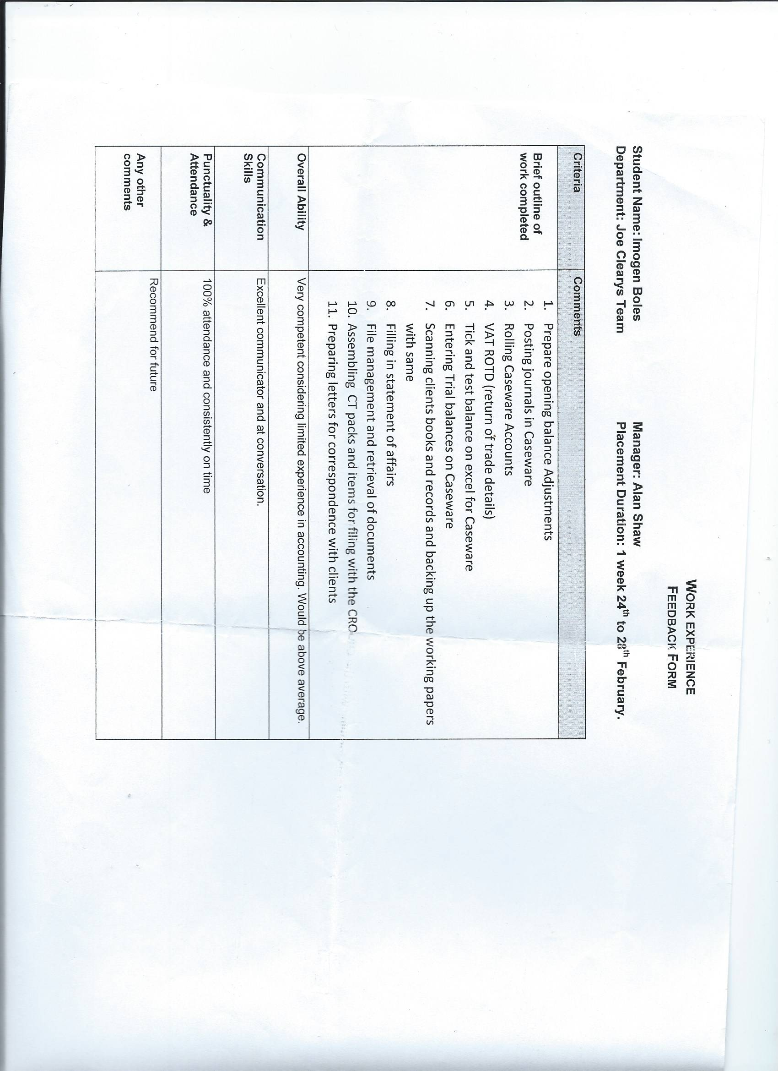

UCD Results to Date:

GPA: 3.75

EU Constitutional Law

EU Economic Law

Criminal Liability

Criminal Offences and Defences

Constitutional Law: Institutional Framework

Constitutional Law Fundamental Rights

Contract Law: Vitiating Factors and Remedies

Contract Law: Formation

Nominate Torts

Negligence and Related matter

General Introduction to the Irish Legal System

General Introduction to Comparative Legal

Property Law I

Property Law II

Company Law I

Company Law II

Human Rights and Social Justice

Inequality and Social Justice in Irish Society

Reason and Paradox

Global Justice

Law and Social Justice Seminar 2

Childhood Inequality in a Global Context

Gender, Power and Politics

Social Justice Movements

Environmental Law and Policy

English Public Law

International Human Rights Law

Migration, Racism and Irish Society

Gender, War and Violence

Disability and Equality

A-

A+

B+

A+

B+

B

A

A-

B+

B+

A-

B+

B+

A

B

B+

A

B+

A-

A-

A-

B+

B+

A-

A-

B+

A

A-

B

A