  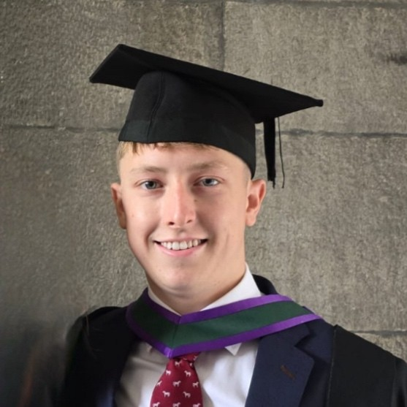 |  | J A Y M A G U I R E  P R O F I L E  I am a driven and self-assured individual with a strong desire to excel in every aspect of life through hard work and perseverance. I am equipped with exceptional problem-solving abilities, with an eye for the finer details of information, which I can utilize to contribute valuable insights and solutions to any organisation. My eagerness and drive makes me a strong team player within any organization, and will allow me to develop my abilities, and learn from esteemed professional’s.  I have just sat my second sitting of the FE1 exams in October, and have completed 1 exam during the March 2023 sitting (Criminal Law – 64%) whilst on professional placement at Philip Lee LLP. I am actively seeking a traineeship for 2026/2027.  --------------------------------------------------------------------------------------------  W O R K E X P E R I E N C E  Corporate Intern Phillip Lee LLP, Dublin (September 2022 – May 2023)  - Was a part of the Commercial department at Philip Lee, primarily within the mergers and acquisition team.  - Worked in tangent with colleagues from intern level to partner level.  - Took part in frequent warranty calls with clients and Associates.  - Was given the first opportunity to draft disclosure letters, compiling disclosure bundles, completion bibles, and transaction ancillaries.  - Regularly completed stock transfer forms and indemnities for lost share certs.  - Took minutes during client meetings.  - Prepared and provided a monthly corporate update memo for all of my colleagues within the department.  Senior Supervisor Spar, Co. Fermanagh (April 2015 – 2023)  - Shift supervisor to many staff.  - Ensured a positive working relationship with staff.  - Trained and supervised co-workers within the store, to a high level.  - Communicated with customers and made recommendations on promotions, to assist in the internal promotion programme.  - Monitored and replenished stock levels, ensuring healthy cash-flow within business.  - Processed cash payments and credit card transactions, ensuring purchases made by customers were swift.  Concierge JW Marriot/ Porsche Dealership Vancouver, Canada (Summer 2023 & 2024)  - Provided exceptional customer service to a diverse clientele, including high-profile individuals and celebrities.  - Demonstrated strong communication and interpersonal skills while interacting with guests in a fast-paced environment.  - Collaborated with hotel staff to provide seamless guest experience.  Enniskillen Royal Grammar  A Level Results – 3A  AS Level Results – 3A 1B  Leaving Certificate Equivalent – 501 points  A Level Subjects  - Business Studies  - Government and Politics  - Religion  - Health and Social Care  S K I L L S P R O F I L E  Leadership: Strong leadership qualities, enhanced and shown through captaining of school rugby team and club rugby teams, also shown through college team projects. Vice captained my local Gaelic club to a league title, and to a championship final.  Communication: Built up and used excellent communication skills through actively working in a busy local retail environment, and also honed through the team sports I partake in.  Interpersonal Relationships: Excellent interpersonal relationships developed through my wide range of work experience and through my sporting background.  IT: Exemplary IT skills: Proficiency in many different software packages including Excel, Word, and PowerPoint.  Public Speaking: Confidence in public speaking and presenting, shown through both school and college work but also through extracurricular activities.

CONTACT
PHONE NUMBER
+447747701808
EMAIL
Jaymaguire67@gmail.com
LINKEDIN PROFILE

https://www.linkedin.com/in/jay-maguire-a780a8232/

ADDRESS

135 Bohermore, Galway, H91 AF5E

ACHIEVEMENTS

- Spearheaded a fundraiser for a close friend who was diagnosed with stage 4 Cancer – Raised 52,000 for Cancer Research
https://gofund.me/78d5d5ad

- Represented Ulster in Youth Rugby

- Represented my county in Underage Gaelic Football

- Attained top of my year in A Level ‘Government and Politics’

- Was a volunteer with St Vincent de Paul Society (Charity)

E D U C A T I O N
Bachelor of Law (BCL) and Business
University of Galway
2020 – 2024
(2.1) Second Class, Uppers Division (67%)
Class Ranking – 13/48
Final Year Modules:
Equity Law, Land Law, Commercial Law, Labour Law, Guided Research Essay (Thesis), Strategy, Human Resource Management, Work in Global Context, Entrepreneurial Venture Development
Third Year:
Professional work placement completed with Philip Lee LLP.
Second Year Modules
Criminal Law, Company Law, EU Law, Moot Law, Management, Human Resource Management, Employment Relations, Cybersecurity and Business Information Systems
First Year Modules
Constitutional Law, Contract Law, Tort Law, Understanding the Law, Financial accounting, Management Accounting, Principles of Microeconomics

Reference name: Eoin Brereton
Corporate Partner at Philip Lee
ebrereton@philiplee.ie
(reference available on request)
Reference name: Karen Armstrong
SPAR store manager +44 7742 503797

Third Level Results at the University of Galway

4th Academic Year | Result
Labour Law 1&2 | 70
Land Law 1&2 | 67
Equity Law 1&2 | 63
Commercial Law | 63
Guided Research Essay (Thesis) | 68
Entrepreneurial Venture Development | 75
Strategy | 66
Human Resource Management | 67
Work in a Global Context | 65
*Overall 67% - 2:1

2nd Academic Year | Result
Criminal Law 1&2 | 68
EU Law 1&2 | 63
Company Law 1&2 | 70
Moot Law | 70
Cybersecurity | 70
Business Information systems | 65
Employment Relations | 62
Management | 72
Human Resource Management | 67
*Overall 67% - 2:1

1st Academic Year | Result
Contract Law 1&2 | 65
Understanding the Law 1&2 | 62
Tort Law 1&2 | 62
Constitutional Law | 61
Financial Accounting | 63
Management Accounting | 64
Principles of Microeconomics | 62
*Overall 63% - 2:1

*3rd Academic year N/A – On professional placement at Philip Lee LLP

