PERSONAL INFORMATION Jennifer Ryan

Apartment 6A, St. Johns Mews, Douglas St., Cork

+353 86 0790032 [jennryan94@yahoo.ie](mailto:jennryan94@yahoo.ie)

Gender Female

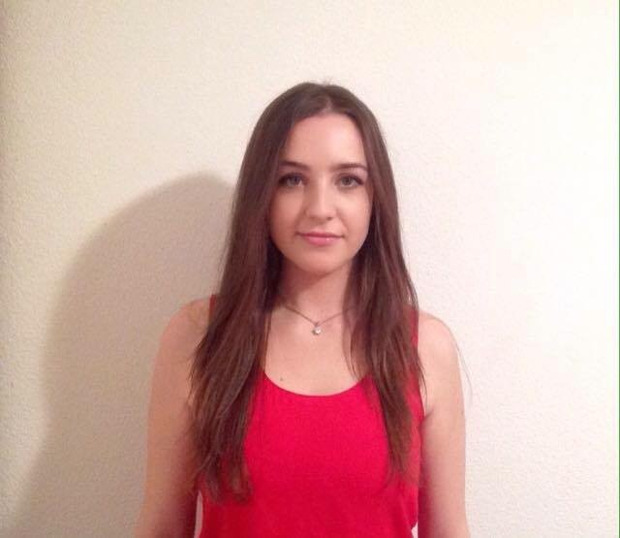

Date of birth 26/10/1994

Nationality Irish

PERSONAL STATEMENT

WORK EXPERIENCE

July 2016 – August 2016

May 2015 – August 2015

April 2010 – May 2015

I am an outgoing and proactive person who loves to meet new people and enjoys working in a team. I also thrive in a leadership role, having captained my Camogie team as well as my Irish debating team. I am highly motivated and I have a very strong work ethic, I have always strived to obtain high results

in school and university while maintaining part-time jobs and being extremely involved in sporting teams and volunteering activities. I believe I will be an asset to your company as I continue to work hard and keep learning while contributing a lot to the company whether doing so in singular roles or as part of a team



Legal Intern

Ronan Daly Jermyn

Throughout my experience in the banking department in a corporate law firm I gained valuable experience and deepened my interest in pursuing a career in law, in undertaking tasks such as scheduling, research work, and writing essays for the company website (<http://www.rdj.ie/insights/a-summary-of-the-implications-of-brexit-for-ireland-s-banking-sector>)

Bar and Waiting staff

Old Head Golf Links ( [http://www.oldhead.co](http://www.oldhead.com)m )

In this employment I worked as bar and waiting staff and gained valuable interpersonal and leadership skills, working both independently and as part of a team on functions and events. Sales Assistant

Catherine Grace Ltd.

In this employment I worked as a cashier, responsible for till takings among other duties. I received training including Customer Service and Quality Control.

May 2009 – August 2015 Childcare Provider

EDUCATION AND TRAINING



2013 - 2017

2013

Bachelors of Law and French EQF Level 6

University College Cork

▪ I am currently in my Erasmus year studying in Université Jean Moulin Lyon III, France

▪ At present I hold a 2:1 average in my studies

Leaving Certificate EQF Level 4

Kinsale Community School, Kinsale, Cork

PERSONAL SKILLS

Mother tongue(s) English Other language(s)

|  |  |  |  |  |
| --- | --- | --- | --- | --- |
| UNDERSTANDING | | SPEAKING | | WRITING |
| Listening | Reading | Spoken interaction | Spoken production |  |

French B2 C1 B2 B2 C1

Irish B2 C1 B2 A2 B1

Levels: A1/2: Basic user - B1/2: Independent user - C1/2 Proficient user [Common European Framework of Reference for Languages](http://europass.cedefop.europa.eu/en/resources/european-language-levels-cefr)

Communication skills ▪ Good communication skills gained through my experience as sales assistant and as waiting staff combined with time spent playing on a sports team communicating in many different environments

▪ Interpersonal skills gained through dealing with customers, clients and team-mates on a personal level every day

Organisational / managerial skills ▪ Leadership skills gained during my time in the Old Head where I would often lead large events and functions

▪ Team work learned while playing GAA where I interacted with the rest of my team as well as younger players throughout my role as both player, and later coach

▪ Time Management and Organisation skills used throughout secondary school and my three years of University. I have always held between two and three part-time jobs, while also being involved in sport and volunteering activities, still maintaining a high attendance record and obtaining a 2:1 average or higher in exams

Job-related skills ▪ Throughout my degree I have gained practical skills in Legal Writing and Legal Systems, as well as studying modules including, but not limited to: Contract Law, Property Law, Law of Torts, Constitutional Law, Economic, Constitutional and Institutional Law of the European Union, Criminal Law and various other modules of the French Civil Law system.

Digital competence

SELF-ASSESSMENT

|  |  |  |  |  |
| --- | --- | --- | --- | --- |
| Information processing | Communication | Content creation | Safety | Problem solving |
| Proficient User | Proficient User | Proficient User | Proficient User | Proficient User |
| ICT-ECDL qualification | | | | |

▪ Good command of office suite (word processor, spread sheet, presentation software)

Driving licence Category B, Category W

ADDITIONAL INFORMATION



Honours, awards and

Achievements

|  |  |  |  |  |
| --- | --- | --- | --- | --- |
| UNDERSTANDING | | SPEAKING | | WRITING |
| Listening | Reading | Spoken interaction | Spoken production |  |

Memberships

Certifications

References

• Student Of The Year Award for Exam and Overall Excellence (Kinsale Community School)

• Player of the Year Award, Cork County Camogie

• Captain of Irish Debating Team (Kinsale Community School)

• Nominated School Prefect (Kinsale Community School)

• All Ireland Medals in Camogie and Regional Medals in Camogie and Gaelic football

• SUAS Literacy Support Mentor and Volunteer

• Red Cross Qualification in First Aid

• Speech, Drama and Communications (Hons) qualification, Royal Irish Academy of Music

• Mr. William Hunter, Managing Director, DavisHunter Auctioneers, +353862223288

• Ms Donna Dempsey, Kinsale Community School, [dodempsey@eircom.net](mailto:dodempsey@eircom.net)