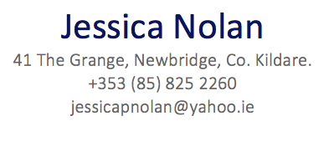 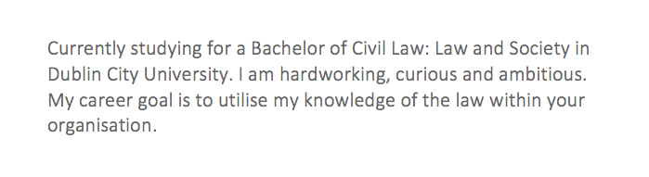

|  |  |  |
| --- | --- | --- |
| Education | **Dublin City University**  **Sep. 2014 - present**   * Strengthened analytical problem solving skills is understanding the role law plays in regulating social systems and critically engaging with the possibilities of law reform. * Gained an understanding of the critical socio-legal perspectives embedded within the delivery of all law subjects while building transferrable skills, including research techniques, and oral and written communication proficiencies. * Excelled in two distinct, in class, moot competitions both at home and abroad. * Participated in a study abroad programme in the University of Stirling which provided experience of life in and observation of another country’s legal system. * Maintained a 2:1 grade average.   **Leaving Certificate 2014**   * Passed seven relevant exams at honours level to obtain the points required for third level education at Dublin City University. | |
| Relevant Experiences | **An Post: Post Person**  **Newbridge, 4 July 2016 - present**   * Attained administrative experience by working in the registration locker. * Enhanced organisational skills through mail assortment and delivery. * Developed a strong work ethic which enabled me to work in a fast-paced environment. * Acquired customer service skills through customer complaints both on route and in the registration locker.   **Hallmark Card Gallery: Shop Assistant**  **Newbridge, Oct. 2013 – Jan. 2017**   * Attained essential skills in sales experience, finance and merchandising. * Acquired strong knowledge in customer relations. * Gained key analytical skills. * Developed organisational and creative skills for shop displays to enhance product promotion. | |
| Skills | Microsoft Office European Computer Driving License (ECDL)  Legal database navigation | |
|  | |