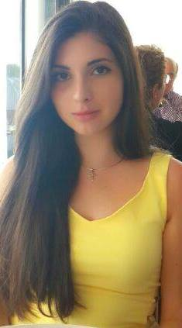**Juliette Marie Charbel**

**Mobile:** 086 1240698

**Email:** [juliette.marie.charbel@gmail.com](mailto:juliette.marie.charbel@gmail.com)

**Address:** Griffith College, South Circular Road, Dublin 8

**Date of birth:** 04/05/1995

|  |
| --- |
| **Education & Qualifications** |

|  |  |
| --- | --- |
| Griffith College Dublin  L.L.B (Hons) in Irish Law seeking to gain experience in practicing law.  European School of Brussels, Belgium  European Baccalaureate:  Biology, Advanced Chemistry, Maths, English, French, History, Advanced Geography, Advanced Philosophy, Chinese | **2013-(2016)**  **2006-2013** |
| **Work Experience** | |

|  |  |
| --- | --- |
| **English Tutor**   * Helping a university undergraduate improve his grammar as well as written and spoken English. Encouraging the spoken language to become fluent and confident.   **Events helper at Byblos International Festival, Lebanon**   * In charge of tickets and seating people for various music concerts and helping with each set-up pre and post-festival.   **Desk Receptionist and Lifeguard at Four Seasons Hotel, Lebanon**   * Trained lifeguard; watching over the swimming pool, ensuring no one drowns or gets hurt. Desk Receptionist as well as managing events.   **Voluntary work at Couleur Café Festival, Belgium**   * Set-up pre and post-festival. During festival, helping to maintain a clean environment as well as being a server at various snack points on site.   **Voluntary work at ‘Serve the City’ organisation, Belgium**   * Worked in the kitchens of an orphanage/retirement home and painting walls of abandoned buildings.   **Voluntary work in Syrian refugee/nomadic camp, Lebanon**   * Worked alongside students from the Lebanese University (UL) documenting and improving living conditions for the Syrian people.   **Auditor in Irish Innocence Project in Griffith College Dublin**   * Worked as translator and proofreading a case with fellow caseworkers.   **Voluntary work for Red Cross in Byblos, Lebanon**   * Worked part-time with school children and Syrian refugees. Furthermore, visited several covenants and hospitals engaging with the elderly and children suffering from cancer. | **June-July 2010**  **July-August 2011**  **June-September 2012**  **June 2013**  **June 2011**  **July-September 2014**  **September-June**  **2015**  **July-September**  **2015** |

|  |
| --- |
| **Skills** |

**Languages** Brought up in Brussels from Lebanese father and Irish mother.

Fluent speaker: English, French. Intermediate: Spanish (GCSE).

Beginner: Chinese Mandarin.

**Computer skills** Competent Microsoft Office user and researching in two different

Languages.

**Extracurricular activities** Intensive water sports such as swimming, sailing, kayaking. Horse-riding.