### PERSONAL Statement

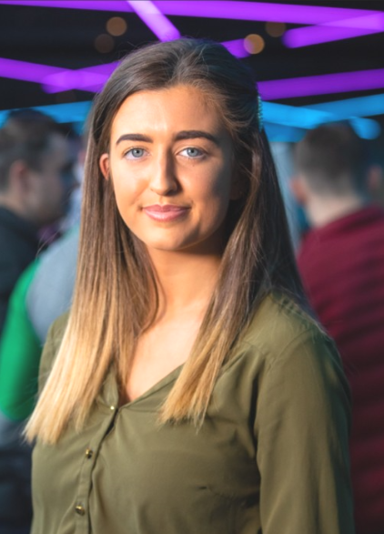

Kate Fallon

*Final Year Law student*

* 086 038 5386
* Kate.fallon3@mail.dcu.ie

**Skills**

Mooting

In 2018 I won the Criminal mock trial which was held by the DCU law society and received best speaker. Achieved a 2.1 in the Moot court module.

Advocacy

Currently acting as Social Events Convener for the DCU Law Society. This involves liaising with law firms and planning online events.

**Hobbies and Interests**

* Currently involved with various charitable and advocacy groups such as GCN and Pieta House.
* Enjoy being outdoors, rock climbing and hillwalking.

A hardworking and adaptable 4th year DCU student. Currently pursuing a career within the legal profession. Eleven months experience in the Employee Relations and Employment Law Department of the daa. I am aware of the hard-working nature and culture of working in the legal industry. Committed to achieving a 1:1 in my degree.

Education

+ Page break

**Bachelor of Civil Law 2017-2021**

***Dublin City University***

Notable results include Irish legal system - 70%, Advanced Torts- 68%, Advanced Property Law - 73%, International Human Rights - 67%

+ Page break

**Secondary School 2012-2017**

***Mohill Community College***

Achieved 451 points in my Leaving Certificate

Extra-Curricular Activities include debating and the Student Council

Work experience

**Legal Intern Sep 2020-Present**

Bruen & Co Solicitors

Provide efficient and effective administrative support to the Managing Partner.

Compiling briefs for counsel and booklets for court.

Establishing professional relationships with clients, including responding to client’s specific information requests and doing everything possible to help them.

**Legal / Employee Relations Intern May 2019-April 2020**

daa (Dublin Airport Authority)

* Attended and supported senior management at Labour Court and WRC Adjudication, Conciliation and Mediation hearings.
* Assisted in the drafting of submissions and preparation of case files for WRC and Labour Court hearings. Handling large amounts of confidential data.
* Experience in the coordination of executive meetings. I planned all meeting with the daa executive team, CEO and unions.
* Assist with the updating of employment policies. This includes reviewing current legislation to ensure that employment-related policies are legally up to date.
* Act as the Employee Relations point of contact with legal and employer organisations. Worked directly with the Employment Department in Arthur Cox.
* Attended High Court personal injuries hearings with the daa Legal and Insurance teams.
* I lead the development of LGBTQ+ awareness for the daa Diversity, Inclusion and Dignity at Work training initiatives.
* Presented Company updates for 100 people on a regularly**+ Page break** basis.

**Camp Counsellor**

**Interviewer Sep 2018-June 2019**

USA Summer Camps

* Worked as a camp counsellor in the USA during the summer of 2018.
* Following my return to Ireland, I was head-hunted by USA Summer Camps to take part in their recruitment campaign.
* Interviewed and assessed individuals looking to work in American summer camps

**Legal Aid Volunteer** + Page break**Feb 2019-June 2019**

Ballymun Law Centre

* Volunteered at the Ballymun Law Centre helping solicitors provide free legal advice, representation, legal education and mediation for individuals and groups within the community.
* Supported Solicitors and mediators in day to day admin duties and at legal clinics.
* I ran the Centre’s Social Media pages.

+ Page break**Referees available upon request**