**CURRICULUM VITAE**

**Lauren Edwards**

12 Aranleigh Court,

Rathfarnham, Dublin 14

Phone: +61 4 05860034

Email: [edwardle@tcd.ie](mailto:edwardle@tcd.ie)

**Personal Profile**

I am focused, hard-working and work well as part of a team. I am friendly and try my best to make those around me feel comfortable. I am enthusiastic and determined and have shown myself to be a quick and a willing learner, capable of adapting to changing environments.

**Education**

**Law Society of Ireland**

**Final Examinations First Part (Entrance exams)**

|  |  |
| --- | --- |
| **Module** | **Grade** |
| Company Law | 56 |
| Equity | 58 |
| Real Property | 57 |
| Law of Tort | 53 |
| Constitutional Law | 57 |
| Law of Contract | 51 |
| Criminal Law | 53 |
| European Union Law | 57 |

**Trinity College Dublin, Dublin 2 - Law LL.B. (2010 to 2014) Result: II.I (69%)**

|  |  |  |
| --- | --- | --- |
| **Academic year** | **Result** | **Percentage** |
| 4th year | II.I | 68% |
| 3rd year | II.I | 69% |
| 2nd year | II.I | 67% |
| 1st year | II.I | 64% |

On the basis of my 1st and 2nd year results I secured a place in Osgoode Hall Law School in Toronto, one of the top law schools in Canada. This was an excellent opportunity to develop an understanding of a different legal system and gain insight into its laws and how they operate. The Canadian teaching method gave me greater confidence in critically analysing laws, identifying underlying policies and forming legal arguments. With the increased work load I had to be productive and time efficient.

**Loreto High School Beaufort, Rathfarnham Dublin 14 (2004 to 2010)**

**__________________________________________________________________________**

**Career History**

**Volunteer- October 2015**

Refugee and Immigration Legal Centre, 121-123 Brunswick St, Fitzroy VIC 3065

|  |  |
| --- | --- |
| * Shadowing and assisting the solicitors * Researching Country of Origin information | * Completing administrative tasks * Carrying out data entry |

**Sales Assistant- June 2015- present**

UGG Australia, Melbourne Emporium, Shop G17, Melbourne VIC 3000

**Sales Assistant- November 2014 to January 2015**

ECCO, Dundrum Town Centre, Sandyford Road, Dundrum, Dublin 16

**Receptionist - September to October 2013**

Harvey Nichols, Town Square 2, Dundrum Town Centre, Sandyford Rd, Dundrum,

Dublin 16.

**Internship - June to July 2013**

Legal Aid Board 48/49 North Brunswick Street, Georges Lane, Dublin 7.

|  |  |
| --- | --- |
| * Drafted letters & compiled briefs. * Prepared memoranda. * Corresponded with solicitors and clients. * Carried out legal research. * Fulfilled administrative tasks. | * Attended and minuted court proceedings both in the Refugee Tribunal and the Family Court. * Met with clients and went through reports with them |

**Child Care Assistant – June to August 2012 & 2011**

Rathfarnham Day Care, Main Street, Dublin 14

**Transition year 2007**

* Attended the Four Courts with Siobhan Phelan BL and Conor Power BL for a two week period.

**________________________________________________________________________**

**Distinctions**

* Trinity College Dean of Students’ Roll of Honour 2014
* Finalist in the Inaugural Free Legal Advice Centre (FLAC) Public Interest Moot 2014.
* One of the authors of FLAC’s publication “A comparative analysis of gender recognition laws” for Transgender Equality Network Ireland.
* Royal Irish Academy High Achievers Award for drama.
* Bronze Gaisce Award.
* Full clean driving licence.
* ECDL certificate in: Concepts of Information and Communication Technology; Using the Computer and Managing files; Word processing; Presentation; Web browsing and Communication.

**References**

* Grainne Brophy

Solicitor in charge

Legal Aid Board

48-49 North Brunswick Street,

George’s Lane, Smithfield, Dublin 7

Tel: +353 1 6469600

Email: [gcbrophy@legalaidboard.ie](mailto:gcbrophy@legalaidboard.ie)

* Tommy Richardson,

SKO Footwear Limited T/A ECCO,

Dundrum Town Centre,

Sandyford Road,

Dundrum, Dublin 16

Tel: +353 87 2562196

**Appendix 1 Exam Results**

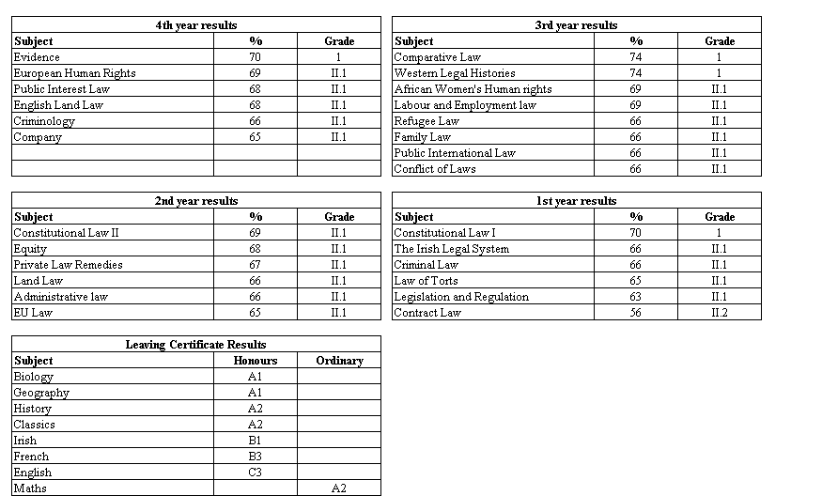

­Note: 1st class honours 70%+