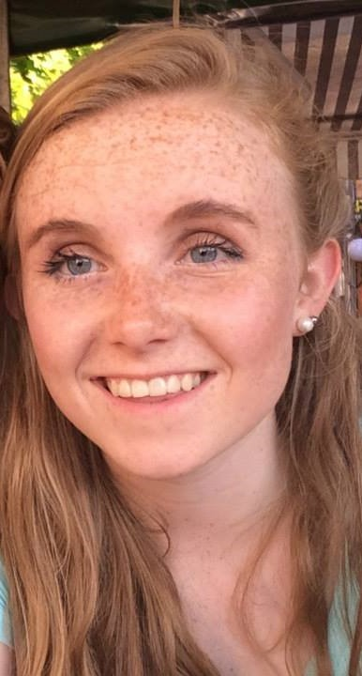
Education
Law and German, Trinity College Dublin 2014 – To date
The King’s Hospital School, Palmerstown, Dublin. 2008 – 2014

Work Experience and Employment History
- Since September 2014 – to date Part Time Volunteer Tuition Programme Co-ordinator
The Voluntary Tuition Programme is a partnership between St. Andrew's Resource Centre, Trinity students, parents and volunteers from the local communities of Pearse Street and Ringsend and Irishtown. Free tuition is offered to secondary school students from inner city Dublin.
Main duties performed:
- Act as a first point of contact to parents for the duration of their child’s free tuition.
- Deal with all enquiries from parents, students and tutors.
- Participate in monthly committee review meetings, and quarter monthly trainings.

- November 2014 – Present Staff Writer University Times
The University Times is Ireland’s largest student newspaper, and is the current Student Publication of the Year. At the Society for News Design’s annual conference in Washington DC last April, the UT won the award for the best-designed student newspaper in the world.

Main duties performed:

- Write for both Features and Opinion of the University Times.( see links)
- Research for assigned subjects.
- Interview relevant sources.
- Draft for Submission to Editor.

Opinion - March 2015 Feature - September 2015

- July 2015 – August 2015 Camp Counsellor Camp Adventure, Germany
Camp Adventure is a residential, two week summer camp that hosts 110 children per camp and specialises in outdoor programs renowned for incorporating an adventurous flair with nature awareness, teamwork and building self-esteem.
Main duties performed (through German);
- I was responsible and ‘in charge’ of 6 children.
- Had nightly meetings where we designed and planned camp activities.
- Implemented the daily schedule, directed and supervised children in spontaneous/planned activities
- Lifeguarded the campers regarding outdoor activities such as kayaking, canoeing and swimming.

- June 2015 Intern Rothkötter, Mischfutter Werk, Germany
Rothkötter is a German company, founded in 1959, that produces feed for farm animals.

Main duties performed: (through German)

- Acted as administrative secretary and receptionist;
- Coordinated schedules for drivers
- Checked expenses
- Screened incoming CVs.
- Gave a presentation about social media and its effectiveness to the Board of Directors.
- September 2014- to date Youth Ambassador ONE Campaign
ONE is an international campaigning and advocacy organization of more than 7 million people taking action to end extreme poverty and preventable disease, particularly in Africa. We raise public awareness and work with political leaders to combat AIDS and preventable diseases, increase investments in agriculture and nutrition, and demand greater transparency in poverty-fighting programs.

Main duties performed:
- Met with Sean Sherlock, junior minister for Foreign Trade to discuss the Government’s aims with Foreign Aid issues, especially economic injustices in these countries.
- Had pieces published in the Meath Chronicle and Lucan Gazette about the work I did. Meath Chronicle - ONE
- Had an interview with LMFM radio station, discussing the ONE Campaign.
- Blogged for Plan Ireland on the issue of gender equality. Plan Ireland
- Met with her local political representatives (D. English, P Toibín and D Hannigan) to discuss their election manifestos.

- October 2014- to date Committee Member Trinity Entrepreneurial Society
Trinity Entrepreneurial Society (TES) is the largest business and careers focused society in Trinity College Dublin.

Main duties performed:

- Member of the Incubator Committee of TES. The Incubator is a 6 month long workshop for selected student entrepreneurs.
- Mentor of one of the groups selected for the Incubator, act as the point of contract between the group and their mentor (100 Minds Founder, Declan Egan).
Organised the weekly events for the Incubator groups;
- make Facebook event to inform others of the event
- Organise food and drinks for the events.
Qualifications
- First Aid qualified
- ECDL qualified
- SUAS Paired Reading mentor
- S2S Mentor in TCD
- Lifeguard
- Piano Teacher ( Grade 8 piano achieved with Honours)
- Full Driver’s Licence
- Volunteer with Meath Diocese in Lourdes

