**Megan Lundy**

[Megan.lundy2@mail.dcu.ie](mailto:Megan.lundy2@mail.dcu.ie)

0876765521

I am an enthusiastic and highly motivated college student. I have a strong work ethic and enjoy approaching new challenges. I have excellent communication skills and work effectively as part of a team. I am a confident and passionate worker and enjoy being presented with new tasks and experiences.

**Career History**



**Customer Assistant**

Boots Jervis Centre (September 2017 – Present)

**Crew Trainer:**

I am an experienced and fully trained crew member given the task of training in new staff members and ensuring tasks and procedures are carried out correctly and to the appropriate standard.

**Cash Trained:**

I am fully trained in the procedure required for counting the store’s total earnings for the day. This involves access to the store’s safes, being responsible for store and safe keys, as well as numeracy skills and liaising with members of security services companies.

**Customer Service:**

Listening to and advising customers in areas including skincare, haircare and cosmetics. Operating tills, carrying out refunds and returns, performing online orders, stacking shelves, dealing with customer complaints.

**Customer Assistant Skills:**

Working in a fast-paced environment, dealing with members of the general public in a professional manner, maintaining a positive and approachable persona.

**Teamwork Skills:**

The entire functioning of the store is dependent on effective teamwork. I have learned the importance of maintaining a positive and communicative relationship with co-workers. This retail experience has shown me the importance of efficient teamwork within an organisation, and how crucial it is in order to deliver an effective service in any occupation.

**Key Skills:**

* Communication
* Teamwork
* Problem solving and critical thinking
* Leadership
* Customer service
* Effective inter-personal skills



**Summer Intern**

Insurance House, Terenure (July 2016)

**Team Member Duties:**

General administrative duties including sorting post, filing forms, inputting information into excel, accompanying staff on postal runs, sitting in on team meetings, answering phones.

**Key Skills:**

Taking instruction and carrying out tasks effectively and to a high standard, asking for help and clarification when I required it, learning to work as part of a team in an office environment, taking feedback on board and applying it moving forward, conscientiously carrying out administrative duties.

**Education**

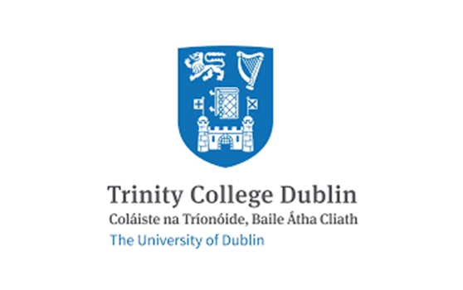**Philosophy BA (Hons)**

(2017 - 2018, completed first year)

* Provides an intensive and in-depth education in philosophical theory, method and practice.
* Completed my first year in this course, after which I moved to law in Dublin City University.
* Although I only completed one year of this course, I gained invaluable skills in critical thinking, problem solving and becoming a more innovative thinker.
* During my time on this course, my opinions and views on existence and the world around me were challenged greatly. I was left with a new passion for questioning my beliefs and a love for analysing moral, social and religious issues.

 **Second year student of Bachelor of Civil Law (BCL)**

(2018 - present, 3 years in duration)

* This degree explores the key foundations of law and how the legal process operates with a relevant focus on how social forces influence the legal profession in a modern society.
* Currently averaging a 2:1 grade; aiming to complete my degree with a 1:1

**1st Year Examination Results:**

Advanced Law of Torts: **73%**

Law of Torts: **67%**

Critical Approaches to Law: **66%**

The Irish legal System: **65%**

Constitutional Law: **63%**

Advanced Criminal Law: **61%**

Advanced Criminal Law: **61%**

Criminal Law: **60%**

Foundations of Law and Legal Research: **60%**

Public International Law: **55%**

**2nd Year Examination Results:**

Family Law: **70%**

Moot Court: **68%**

Company Law: **68%**

Advanced Property: **66%**

Advanced Contract Law: **65%**

Healthcare Law: **65%**

Contract Law: **61%**

Advanced Company Law: **61%**

Advanced EU Law: **61%**

Property Law: **57%**

EU Law: **53%**

**Graduated from Dominican College Griffith Avenue**

* Completed the Leaving Certificate in 2017
* Obtained 500 points

**Leaving Certificate Results:**

* English H2
* Biology H2
* History H2
* German H2
* Home Economics H3
* Maths H6
* Irish O4

**Hobbies and Interests**

* Health and fitness
* Reading
* Meditation

**Achievements**

Awarded a place on the Law Society of Ireland’s transition year programme

Taught classes in computer proficiency to older people in the area

Volunteered in St Andrew’s Resource Centre, assisting in the creche as well as the organisation of events for older people in the community