**Curriculum Vitae**

|  |  |
| --- | --- |
| **Name:** | Niall Guinan |
|  |  |
| **Home Address:** | 57 Bloomfield Drive, |
|  | Coosan, |
|  | Athlone, |
|  | Co. Westmeath. |
|  |  |
| **Date of Birth:** | 19th May 1993 |
|  |  |
| **Phone:** | 0876464067 |
|  |  |
| **Email:** | guinann@tcd.ie |

**Education**

2005 - 2011

Athlone Community College,

Retreat Road,

Athlone,

Co. Westmeath

**Leaving Certificate**

|  |  |  |
| --- | --- | --- |
| **Subject** | **Level** | **Grade** |
| Mathematics | Ordinary | A1 |
| English | Higher | A1 |
| Irish | Higher | A2 |
| French | Higher | B1 |
| History | Higher | A1 |
| Business | Higher | A2 |
| Biology | Higher | A2 |
| Music | Higher | A1 |

I successfully completed the Transition Year programme at my school in 2008/2009.

I am currently studying in the Masters in Law (LL.M) programme at Trinity College Dublin.

I obtained a 2.1 in my undergraduate degree in Law and Political Science (LL.B Pol. Sc.), also at Trinity College Dublin. A full transcript of my exam results throughout my degree is attached.

I sat the TCD Foundation Scholarship examinations in January 2013.

**Other Qualifications and Achievements**

I have an ECDL certificate (2009).

I have a Gaisce Bronze award (2009).

I have a licentiate diploma (honours) in piano with the Victoria College of Music, London and I have taught piano to a number of students (2010).

I was appointed as a Senior Prefect in my school in September 2010.

In January 2011, I was a prize winner in the UCC Faculty of Law essay competition.

In May 2011, I received my school’s Academic Excellence award at our end of year awards ceremony.

I received an Entrance Exhibition award to Trinity College, Dublin in 2011 on the basis of my Leaving Certificate results.

I received the Barra Flynn Memorial Scholarship from Tormeys Solicitors in Athlone in 2011 on the basis of my Leaving Certificate results.

**Experience**

Work Experience in St. Vincent’s Day Care Centre, Abbey Road, Athlone, Co. Westmeath. (November 2008)

Work Experience in the “Athlone Voice” newspaper, Sean Costello Street, Athlone, Co. Westmeath. (November 2008)

Work Experience in Coosan National School, Castlequarter, Coosan, Athlone, Co. Westmeath. (February 2009)

Senior Prefect in Athlone Community College, Retreat Road, Athlone, Co. Westmeath. (2010/2011)

Junior Editor, Volume XXII of the Trinity College Social and Political Review. (2011/2012) Senior Editor, Volume XXV of the Trinity College Social and Political Review. (2014/2015)

Intern in Hugh Campbell and Co. Solicitors, Shannon House, Costume Place, Athlone. (June/July/August 2013).

I am currently working as a caseworker with the Irish Innocence Project based in Griffith College Dublin which involves investigating possible cases of wrongful conviction and miscarriages of justice.

I have volunteered with Amnesty International. I have also volunteered with the Trinity branch of the Free Legal Advice Centre (FLAC), in particular with the transgender rights research project of 2015. In addition, I volunteer with ShoutOut which provides anti-homophobic bullying workshops in Irish schools. I have spoken at debates with the TCD University Philosophical Society.

I have been an active member of Qsoc-Trinity LGBT throughout my time as an undergraduate and have been on their campaigns team since my first year. I have helped organise particular campaigns related to marriage and assisted in designing leaflets and posters to raise awareness of transgender issues.

I have also been an active member of Young Fine Gael, particularly the Trinity branch as a committee member in my third year but also in the wider organisation. I have done some work for local and European election candidates and was actively involved in the marriage referendum campaign in May 2015.

I have written articles for *The* *University Times* and for *The Irish Catholic* as well as written contributions to literature for Qsoc-Trinity LGBT and for FLAC.

**Referees**

Professor Ivana Bacik, Coordinator of the Law and Political Science Degree Programme, School of Law, Trinity College Dublin, [icbacik@tcd.ie](mailto:icbacik@tcd.ie).

Eileen Donohoe, Principal, Athlone Community College, Retreat Road, Athlone, Co. Westmeath. 0906472625 [info@athlonecc.ie](mailto:info@athlonecc.ie). (attached)

Chris Flood, Editor-in-chief, Volume XXII, TCD Social and Political Review. [floodcb@tcd.ie](mailto:floodcb@tcd.ie). (attached).

Hugh J Campbell, Hugh J Campbell and Co. Solicitors, Shannon House, Costume Place, Athlone, Co. Westmeath, 0906472015.

Signed:_______________________

Niall Guinan

Date: 14th October, 2015.

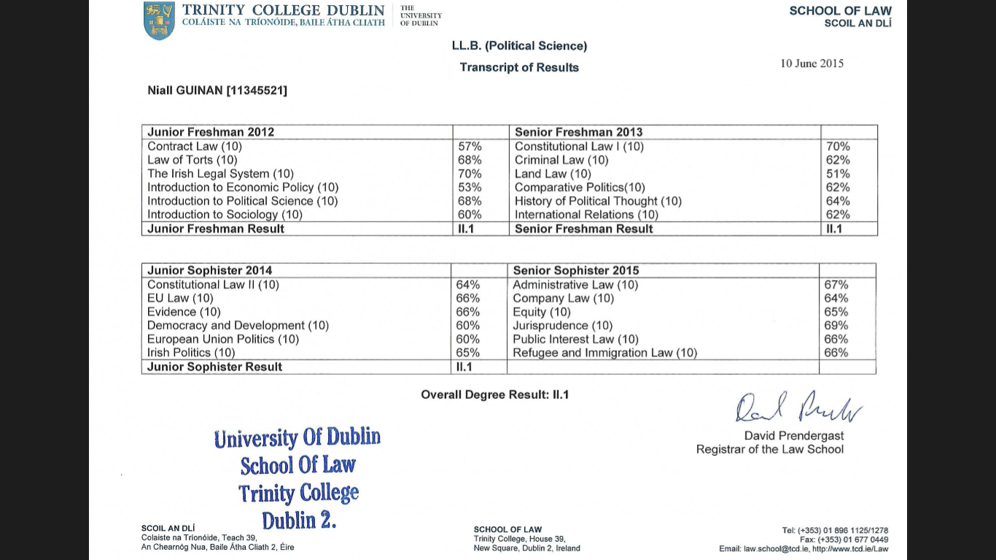

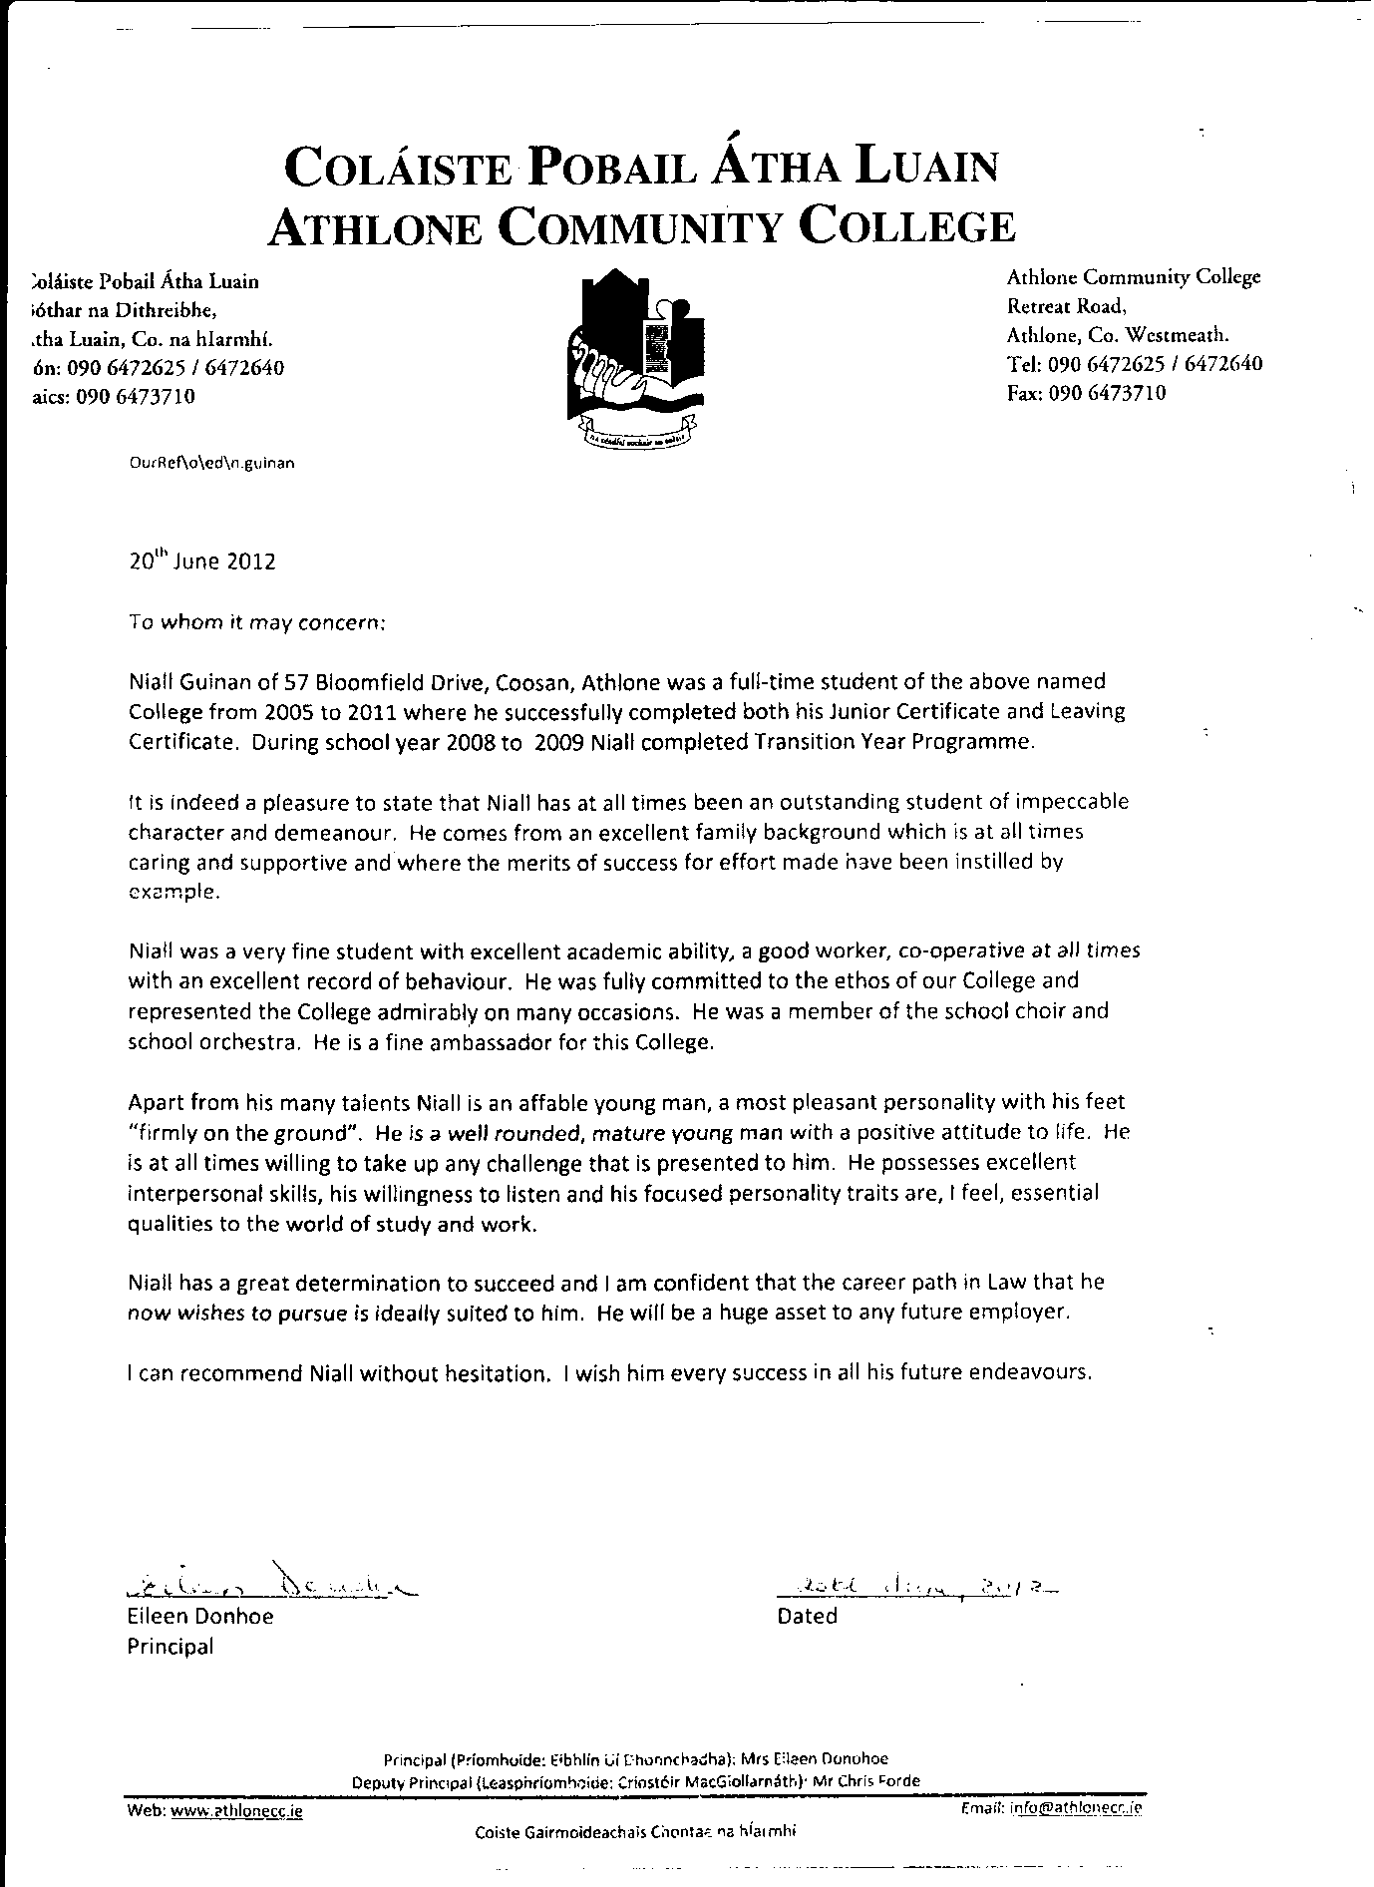

13 May 2012

To whom it may concern,

I am a third-year law student at Trinity College, Dublin. I was Editor-in-Chief of Volume XXII of the *Social and Political Review*, an academic journal at Trinity College, focused on the social and political sciences. Niall was a member of the Junior Editorial Board of Volume XXII.

Niall’s responsibilities included assessing and selecting articles for publication, editing academic articles, liaising with authors, and participating with the rest of the team in the general running of the journal and organisation of events, including the annual SPR Panel, which this year took the theme of ‘Changing Ireland: Shaping Our Future,’ and featured experts such as Professor Gerry Whyte (TCD), Noelle O’Connell (European Movement Ireland), Michael Barron (BeLonG To) and Brian Whiteside (Humanist Association of Ireland).

I found Niall to be an extremely competent editor. He completed all of the tasks assigned to him in a professional manner, adhered to strict deadlines, and produced work of excellent quality. Niall was an integral part of the team. He worked very well with other board members, and was able to both follow direction and work independently. I believe Niall would be an excellent addition to any organisation and I have no hesitation in recommending him for this position.

With best wishes,

Chris Flood