**Ollin Flynn**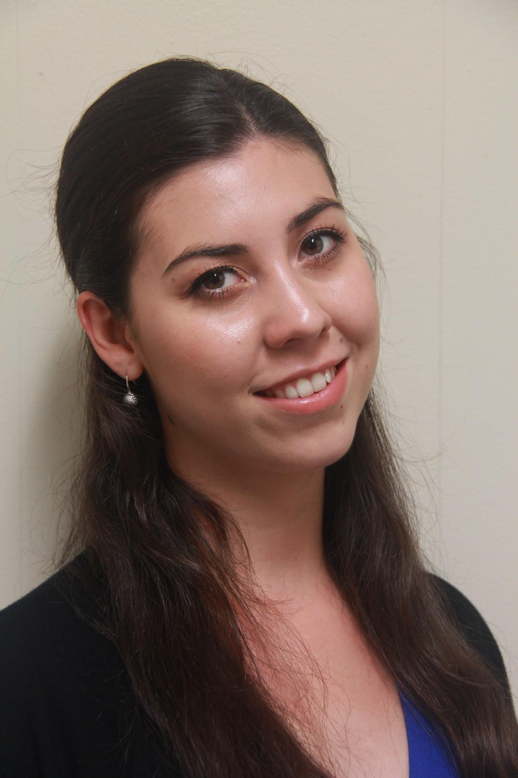

44 Joyce Road, Drumcondra, Dublin 9

[olflynn@tcd.ie](mailto:olflynn@tcd.ie)

(087) 9117336

Education

|  |  |
| --- | --- |
| 2013 - 2017 | Trinity College, the University of Dublin, Ireland  B.A. (Mod) Business and Political Science  Result 2.1 (65%) |
| 2006 - 2013 | St. Louis Community School, Kiltimagh, Co. Mayo, Ireland  Leaving Certificate Higher Level  505 points |

Work Experiences

Sales Associate Tommy Hilfiger, Grafton Street, Dublin 2 November 2017 - Present

* Responsible for greeting and delivering top quality service to customers in the Irish flagship Tommy Hilfiger store.
* Regularly manage and appease customers with their various queries and complaints.
* Regularly beat incentives and receive rewards as well as complimentary customer feedback.

Sales Associate Reiss, Grafton Street, Dublin 2 June 2015 - August 2016

* Worked towards individual and team sales targets successfully.
* Ensured that customers were treated with the highest level of professionalism in line with Reiss standards and training.
* Responsible for styling customers and taking initiative when selecting outfits to ensure they fit customer needs and suited their tastes.
* Took part in the annual Reiss fashion show in London.

Internship Orion Resource Partners, New York June 2014 - August 2014

* Developed excellent verbal and written communication skills. Responsible for managing calls and emails with various stakeholders, for example, liaising with delivery services, handling investor calls, booking meetings and enquiring about numerous services as requested by staff.
* Developed a method of organisation of company files and ensured that filing was kept up to date and took initiative to carry out tasks when work was not dictated to me directly.
* Ensured that office supplies were always kept available and plentiful.

Office Assistant Olandi Engineering, Straide, Co. Mayo June 2011 - December 2012

* Responsible for filing company documents and carrying out research into various company matters. Developed a first hand understanding of the running of an SME in Ireland.
* Answered phone calls and emails from various stakeholders when needed.
* Ensured that the office, canteen, and workshop were kept in a tidy manner for health and safety purposes.

Extracurricular Activities

Active member of DU Fashion Society September 2015 - May 2017

Trinity College, the University of Dublin

* Aided in the organisation of the annual “into the woods” themed fashion show in 2015. Walked in the fashion show, the proceeds of which went to charity.
* Went on the annual London fashion week trip. Attended as many fashion shows as was feasible over the long weekend.

Student 2 Student Peer Mentor September 2014 - May 2015

Trinity College, the University of Dublin

* Welcomed incoming students from Ireland and abroad into the university.
* Responsible for giving students a full tour of campus during orientation week and remained a constant contact and source of support for any queries or problems they had.
* Organised events to assist in assimilating students into college life throughout the year.

Co - Founder of Cumann Youth Club September 2009 - May 2011

Mayo, Ireland

* Attended irish speaking summer camp for five years in a row and became a camp leader.
* Assisted in setting up the first Cumann na bhFiann Irish speaking youth club in Castlebar in county Mayo.

Competitive Irish dancer September 1998 - August 2013

Mayo, Ireland

* Started dancing at the age of four and danced competitively until the age of eighteen.
* Danced at major competitions in Ireland and abroad, for example, the world championships in Glasgow, Dublin, Belfast and Boston.
* Took part in solo and team competitions.
* Developed useful skills for example I have strong self confidence from performing in front of large crowds and dedication when working towards a goal.
* Place a great deal of importance on living a healthy and active lifestyle to stay focused and able to take on any challenge that may arise.

References Available on Request