RorySugrue

Personal Details

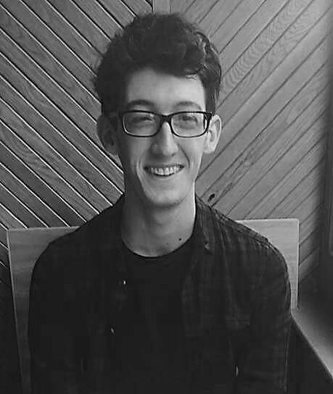**Name**: Rory Sugrue

**Address**: 70.4.3, Goldsmith Hall, Westland Row, Dublin 2

**Contact Details**: (+353) 87 699 2488

rsugrue@tcd.ie

**Date of Birth**: 28-10-1995

**Nationality**: Irish

Work Experience:

* September 2016-June 2017: **Bartender, Kelly’s Irish Pub Mainz, Germany**

I decided to obtain a part-time job while studying in Germany. The intention was to mainly help improve my language abilities, which indeed it did. I also acquired significant managerial and other team related skills. I was given many duties and responsibilities while working here.

* June-August 2016: **Tax and Legal Intern, German-Irish Chamber of Commerce and Industry**

I was required to fiscally and legally guide both Irish and German clients. I had to support the head of the department with his tasks as well as creating PowerPoints and proof reading English language documents and correspondence. I was also required to regularly carry out reception duties for the Chamber.

* August 2014: **Office Assistant, Thomas J O’Halloran’s Solicitors Office**

I performed general tasks for the office including; printing, copying, filing and delivering letters. I also had the opportunity to attended court.

* July 2014: **Language Assistant, Diverbo, Spain**

I spent two weeks as a language assistant and camp leader where I organised engaging activities to help Spanish students to improve their English language skills.

* January 2012 - Sep. 2013: **Volunteer Youth Worker, KDYS Tralee**

I organised events for young people in the area. I was responsible for fundraising and budgeting.

Education:

**September 2014 – May 2018**: Trinity College Dublin

* Law and German LL.B. (ling. germ.)
* Erasmus in Johannes Gutenberg-Universität Mainz, Germany (2016/17)

**September 2008 – May 2014**: Gaelcholáiste Chiarraí, Tralee, Co. Kerry

* 2010: Junior Certificate - 9 Honours in all Higher-Level Subjects
* 2014: Leaving Certificate - 525 points from 6 Honours in Higher Level Subjects: Irish, English, Maths, German, Business, Geography and History

**September 2001 – May 2008**: Gaelscoil Mhic Easmainn, Tralee, Co. Kerry

Language Abilities:

**English** – Native speaker

**Irish** – C2 according to the CEFR; fluent in both written and spoken

**German** – C1 according to the CEFR; competent in both written and spoken

Hobbies:

* I have a keen interest in water sports including rowing, surfing and swimming.
* I am a member and coach in Tralee Rowing Club and a member of Dublin University Boat Club.
* I enjoy reading, traveling, cooking and volunteering.

Achievements:

* + Distinction in “Level 5 FEETAC Occupational First Aid”.
  + “Microsoft Office Specialist” qualification in Excel and Word.
  + Chairperson of the TCD Germanic Society and
  + Education Officer of the TCD Voluntary Tuition Programme.
  + Qualified Student2Student Peer Supporter and Student Mentor in Trinity College Dublin.
  + Nominated three times for “Student of the Year” during my final years in secondary school.
  + “Level 1 Rowing Coaching” course and “Code of Ethics in Sports” programme completed.

Referees:

Mary Boner

**Rowing Coach**

Tel: (+353) 86 836 6943

Patrick Bamming

**German-Irish Chamber**

Tel: +353 (1) 642 4300

Katrin Eberbach

**Lecturer**

Tel: +353 (1) 896 3469