# Sean Harrison

*Home Address:* 21 Foxborough lane, Lucan, Co. Dublin.

Email: harrosean@gmail.com

Mobile: 0894064542

## Education

(2014 – To date) Maynooth University, Maynooth, Co. Kildare.

**LLB Law Degree**

*Expected Result: 1.1 Honours*

(2008 – 2014) John Scottus Senior School, Donnybrook, Dublin 4.

**Secondary School Education**

##### Employment

(July 2011 – Date) Irish *Relo*, Clane Road, Kildare

Relocation company. Involves: Export wrapping, Warehouse work, and European relocations, communication with representatives of multi-national corporations

**Work Experience:**

July 2017 *Sheridan Quinn Solicitors*, Pembroke Road, Dublin 4.

I spent a month working under a private practice solicitor named Peter Quinn, as well as some of the other solicitors employed within the practice. During my time working there I gained a lot of experience as well as a lot of insight into the legal profession via court attendances, researching legal information, drafting letters to clients, attending consultations and settlement negotiations. I found working with Sheridan Quinn extremely useful as it enabled me to make connections within the profession I wish to pursue a career in.

October 2011 *Sean Costello & Company Solicitors*, Smithfield – Transition year work experience.

(General office work, transportation of documentation, courtroom observations, documentation, evidence review).

**Interests and Activities**

***University:* Maynooth LawSoc Member (2014 – To Date)**

###### Sports: Lourdes Celtic Football Club – (2000 - 2014)

* Played soccer with this club from academy until under 18’s (At which age they offer no senior teams)
* Received a long-term service award.
* Club funded my coaching licences and approached me to coach an underage team.

**Woodfarm Football Club – (2016 - To Date)**

* Captained the team for a period of time.

**Neilstown Boxing Club – (2004 – 2014)**

* Boxed both competitively and non-competitively for this club.
* Often coached part of training sessions for younger kids.

**John Scottus School Hockey Team – (During 2nd Level Education)**

**John Scottus School Soccer Team – (During 2nd Level Education)**

* Played consistently for the school team throughout education.
* Captained the team in final year.
* Aided in organizing after school training sessions and encouraging fellow pupils to participate.

#### Other Qualifications

* FLAC Certified – Maynooth University.
* Full (ROI) Driving Licence since May 2015.
* Kick Start 1 Certificate.

##### Other Achievements

* ***Spent 3 weeks in India* (October 2011)**

I travelled with my fellow fourth year students accompanied by teachers to a region in India called the Sunderbans. In my time there I assisted in the construction of a school, which involved co-operating well with my team and working through harsh conditions in order to ensure we reached our overall goal in our designated time frame.

* ***Organised a charity fight night.* (March – May 2012)**

Also in fourth year I was approached by my teacher about organising a fight night in aid of two separate charities; those being The Ronald McDonald House & Doctors for Jharkali. I took on the task with some assistance from other members of my class. It involved having to organise numerous things for the night to succeed. These are things such as booking the venue, organising a chef to cater for the night, arranging participants (such as teachers, students and past students) to fight on the night, arranging a trainer to ensure the fighters were held a sufficient level of fitness to participate (I also assisted in taking the training sessions given my own experience boxing), designing both the tickets and programme for the event, contacting a printer to print them and finally approaching local businesses to sponsor the event. The event resulted in a sell-out, selling over two hundred and fifty tickets. The event raised over four thousand euro, which was then divided equally between both charities. This event took place over a ten-week time frame, which has helped my time management and working under time constraints as well as my co-operation and delegation skills.

* **John Scottus Senior School ‘Sports Boy of the Year’ 2014**

An award received for my contribution to the sports department within the school.

* **John Scottus Senior School ‘Spirit Award’**

An award received for my enthusiasm towards extra-curricular activities.

**REFEREES**

To Whom It May Concern:

Re: Sean Harrison

I was Headmaster of this School during all of Sean’s schooling, in Primary and Secondary. He was a young man for excellent qualities, and he was much liked for all of those years: he was incredibly reliable and punctual; he was very respectful and mannerly; he worked very hard, and was rewarded with a respectable Leaving Cert. at the end of his schooling. He participated and enjoyed everything that the school offered, and seemed to show his appreciation all the time. He was a great supporter of this school.

In his final two years he showed that he was a good organiser: he did a wonderful job in organising the National Stadium to host a ‘Fight Night’ for the school, and he managed to get a number of members of staff, including myself, into the ring. But he also organised training sessions each week for many weeks to get us all fit and up to the mark. Nothing was going to go wrong and it didn’t. He was also a great supporter of sports in the School, and was very involved in soccer outside the school.

Up to the end of his final year he was an excellent member of this school community, and was much appreciated by all the school’s students and by all members of staff.

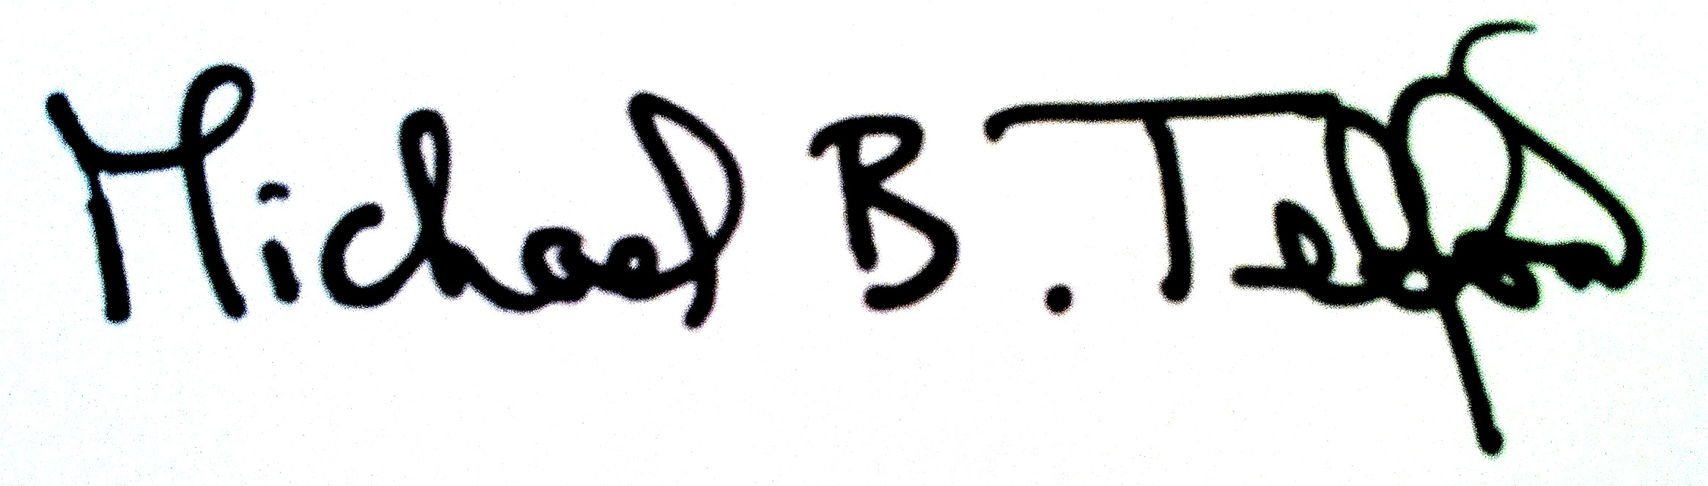

Dr. Michael Telford,

John Scottus School.

To whom it may concern,

Re: Sean Harrison

Sean Harrison was a Transition Year student of mine in John Scottus School, Donnybrook, Dublin 4.

He was exemplary in his work and his behaviour and I highly recommend him as a trustworthy and helpful young man.

In addition to his excellent behaviour Sean showed good innovation skills by organising and running a boxing fund raiser in the National Stadium, Dublin in aid of an education project near Kolkata, India, which he also participated in.

https://ssl.gstatic.com/ui/v1/icons/mail/images/cleardot.gif

John Alexander  
TY Coordinator  
John Scottus School  
76 Morehampton Rd.,  
Dublin 4  
0874182415

##### Other Referees

Prof. Michael Doherty Mr. John Grimes

**Head of Law Department/Lecturer Operational Manager**

##### Department of Law Irish Relcation Services Ltd.

Maynooth University Portgloriam, Clane Road, Kilcock

National University of Ireland Maynooth Co. Kildare

Maynooth, Co. Kildare Tel: 0851181083

Email: michael.b.doherty@mu.ie Email: john.grimes@irishrelo.com