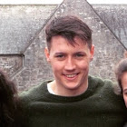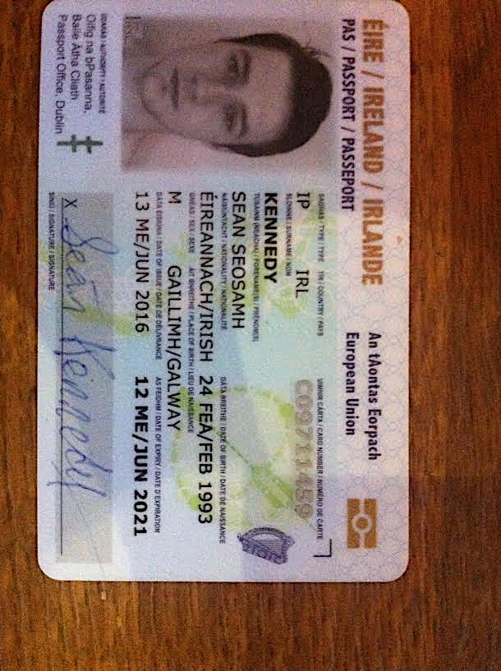

**PERSONAL INFORMATION**

 14 Tara Grove, Wellpark, Galway.  086-3714426

 skennedy1234@gmail.com

**Sex** Male

**Date of birth** 24/02/1993 (23yrs) **Nationality** Irish

**Work Experience**

**Horkan’s Petworld (2009 - 2016) - Sales Assistant**

I have worked cohesively within the Petworld team for over 7 years. My main contribution to my branch and company has been growth and expansion, boosting sales, implementing the CPC - Customer Prompt Card and extending and promoting its customer base.

* All till operations / System updates
* Customer service and queries
* Processing deliveries / Goods inwards / Supplier returns / Communicating with supplier representatives
* Processing paperwork / Ensuring correct stock figures
* Cherry picked as part of team to open new branch outlets

**John F. Martin Solicitors (August 2015 – January 2016) – Legal Executive**

* Office administrative duties – preparing documents for Judge and Counsel
* Banking duties - lodging monies into client accounts
* Drafting letters / Filling out prerequisite forms
* Reviewing State evidence
* Attending on a barrister / Attending District & Circuit Court
* Debriefing clients
* Speaking and dealing with clients and Gardaí

**Education**

**Leaving Cert.** Calasanctius College – 460 pts.

**PLC**. **Furniture Making & Design** – 8 Distinctions

**Materials Science & Technology 2012 - 13** University of Limerick

Modules: Materials, Chemistry, Engineering Science, Manufacturing Technology, Machining Technology, Material Processing, Communication Graphics, Technological Mathematics.

**Law Degree 2013 - 17.** University of Limerick – 1.1 expected

Penultimate Year results: A1, A2, A2, A2, B1. 3.6 QCA.

**Achievements**

* Receiving a personal letter from Pascal Donohoe TD in response to my letter voicing a concern pertaining to the Road Traffic Act, in which he describes the content of my letter as "very prudent" and "impressed with my understanding of what is a surprisingly knotty area of the law."
* Presidents Letter for outstanding academic achievement - 2016

**Personal Skills**

**Communication Skills - very proficient.**

* I possess a strong ability to communicate clearly and coherently with customers, co-workers and superiors.
* I have been involved in various presentations in College and have obtained a distinction from the Irish Royal Academy for public speaking during my Transition Year in Calasanctius College.

**Team Work Skills – well developed.**

* Every year the Petworld team pulls together to organise the furry 5K walk in aid of charity. Over the years it has always been a successful and fun day out for all. This July, 60 people took part and we raised over €1400 for Autism Assistance Dogs Ireland.
* I have played competitive soccer for over 14 years.
* I have been involved in numerous team assignments, presentations and moots.

**Problem Solving**

My abilities to problem solve and my analytical skills have been developed from lessons learnt from experience, acquired wisdom and working and dealing with the general public. On many occasions I have displayed and demonstrated skills by overcoming difficult situations in a logical fashion and resorting to my refined skills, for example:

* Dealing with difficult customers or people and offering solutions.
* Communicating with a deaf man and wife.
* Communicating with a Spanish client through an interpreter.
* Undermining competitors promotions.

**Computer Skills**

* ECDL qualified / Very proficient with all Microsoft software & packages

**Staff Reviews**

Obtained highest grade in all staff reviews which endorse:

* I am a committed and dependable individual with an excellent punctual record -over 7 years.
* Demonstrated high level of competence and consistency on many occasions.
* Experienced logical team player with a proven ability to work effectively on my own initiative.
* Considered a respectful member of staff with strong interpersonal skills & looks out for fellow staff members.

**Additional**

* Full/Clean Driving licence
* Qualified in First Aid
* Qualified in Manual handling

**Hobbies & Interests**

* Keeping fit and in good shape - I run regularly around the UL campus and on the weekends I run in Coole Park or on the Salthill Promenade.
* I am a member of the Active Fitness gym, leisure and social club.
* I am particularly fond of the card game 25.
* Mega boxing fan.

**Other**

* I have learned the tools to client collection and retention i.e. relationships, expertise, integrity, performance, delivery, consistency and going above and beyond.