Sorcha  o’loughlin  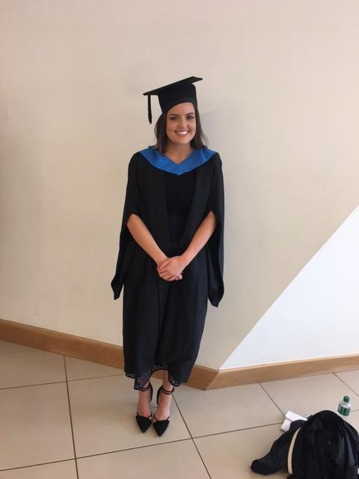 | 36 Templemore Avenue, Rathgar, Dublin 6  014967124  0830493390  Sorcha.o-loughlin@ucdconnect.ie

I am a twenty two year-old Commerce graduate and currently sitting the FE1s hoping to pursue a career in law. I am a motivated self-starter who adapts and learns quickly. My years of experience working in retail alongside completing my degree have honed my communication skills, as well as my ability to multi-task. Graduated with a 2.1, was very happy with this result.

Education

Bachelor of Commerce | University College Dublin
2014 - 2018
A globally recognised business degree for ambitious and achievement oriented students. Four years of assignments, presentations and team projects. Subjects taken include digital/e-marketing, several accounting modules, economics, finance, corporate governance, and customer behavior/psychology modules.

Leaving Certificate | Loreto College, St. Stephens Green

2000 – 2014
All subjects taken at higher level. Achieved 510 points

Experience

Stylist | Karen Millen, Brown Thomas, Grafton Street

October 2018 - Present
Stylist and sales assistant for Karen Millen in Brown Thomas, individually styling customers, selling, managing luxury items and providing excellent and attentive customer service.
I am regularly top-sales person on my shifts.

Sales Assistant | Maje, Brown Thomas, Grafton Street

Feb 2017 – Sep 2018
Sales assistant in the busy Maje concession on a part-time basis. I maintained the high standards Brown Thomas expects on the floor throughout the day, personally assisting customers, with sizes and styling, managing luxury items, and providing excellent and attentive customer service.

Sales Assistant | Kurt Geiger, Brown Thomas and BT2, Grafton Street

Dec 2014 – Jan 2017
I worked as a sales assistant for Kurt Geiger for over two years on a part time basis, gaining experience handling luxury products, designers, and providing excellent customer service. I worked well within a dynamic and busy team.

Childcare Assistant | Highfield Montessori School

Summer 2014
Assistant in the classroom with children aged two to five. Helped with annual class planning, organization of the calendar and report writing, as well as day-to-day work on classroom floor.

Reception Staff | Media Works

March - April 2014
Worked on the reception desk at this media and advertising company, which involved answering the phone, dealing with concerns and complaints, completing the company calendar. I also worked on a customer survey during this time.

Administrative Staff | Niall D Brennan Associates

October 2014
Worked in a busy office, both on reception desk and internal administrative work. The job involved managing phone calls, dealing with clients, and assisting with the organisation of this architecture firm.

Babysitting | Local families

2008 – Present
Have been babysitting for many families for nearly 10 years! My responsibilities include putting babies - teens to bed, cooking dinner, checking homework, etc. Very comfortable with children and passionate about looking after them whilst having fun.

Skills

- Strong communication skills  - Excellent multi-tasker  - Mathematical aptitude | - Proficient with computers  - Keen organisational skills  - Time – management

Activities
- Promotions and Productions Officer for the Commerce and Economics Society (C&E) in University College Dublin (UCD)
  - Role included managing the C&E main annual events including the annual UCD Commerce Ball and European Mystery Tour
- Volunteer for the Irish Wheelchair Association
- Member of Student Council 2014
- Member of the Art Committee 2013
- Winner of Sports Award, Loreto College 2014
- Sports Captain – basketball 2013 – 2014
- Qualified in Emergency First Aid since 2012 – European Red Cross
- Proficient in Gaeilge (Irish)
- Hobbies include hockey, basketball, training at the gym, and photography

