

**OVERVIEW**

Thank you for choosing Vuture as your new email-marketing platform.

You have received this document because you are about to embark on configuring your InterAction CRM with Vuture’s email-marketing software.

This document will guide you through the simple process and list all the requirements you need in order to complete a successful configuration.

In order to help you through the process we have highlighted the areas in yellow that require your input. If you see the below:

|  |  |
| --- | --- |
|  | ACTION REQUIRED |

This means that you will have to fill in the detail required. Don’t worry there is plenty of explanation to help you.

**YOUR VX DETAILS**

This URL is the address in which Byrne Wallace access their Vuture platform:

|  |  |
| --- | --- |
|  | [https://byrnewallace.vuture.net](https://byrnewallace.vuture.net/) |

Email recipients who click on email links through to landing pages and/or forms will be directed to URLs using the following format:

|  |  |
| --- | --- |
|  | [https://sites-byrnewallace.vuture.net](https://sites-byrnewallace.vuture.net/)/id/pagename.aspx |

**SETTING-UP YOUR INTERACTION**

Identify the technical contact for the InterAction set-up:

|  |  |
| --- | --- |
|  | NAME & EMAIL |

Identify the InterAction client advisor at Lexis Nexis. (If applicable)

|  |  |
| --- | --- |
|  | NAME & EMAIL |

**CONNECTING VX TO YOUR INTERACTION**

In this section you will find the details of the steps you need to take for Vuture to integrate the Vuture platform with your InterAction application server.

**Step 1: Open port (443) and allow for incoming HTTPS traffic from the two IP address of your Vuture server, which your Vuture project manager has provided.** [These *IP Addresses are on following pages*]

|  |  |
| --- | --- |
|  | HAS THE PORT BEEN OPENED? |

**You will need to set up a valid security certificate for the secure connection.**

|  |  |
| --- | --- |
|  | HAS YOUR SSL CERTIFICATE BEEN SET-UP? |

**FIREWALL SETTINGS**

**Step 2:** In order to connect to your InterAction we need a route through to your InterAction server from the two IP address over port 443. The IP numbers are below.

IPs:         [Vuture] **94.236.91.184**

                [Vuture] **217.138.46.58**

|  |  |
| --- | --- |
|  | IP SET-UP? |

**Step 3:** HIGHLY IMPORTANT: Please ensure that your IT/Network team whitelist the Vuture server IP addresses to ensure emails can be received internally from the Vuture platform. These include test emails, passwords reset and approval notification emails.

|  |  |
| --- | --- |
|  | SERVER IP ADDRESS IS WHITELISTED? |

**Step 4: FIREWALL SETTINGS:** Please whitelist the following IP addresses on the firewall between the Vuture platform and your InterAction application server. This will ensure emails can be received internally from the Vx platform. These include test emails, passwords and approval notification emails.

IPs:         [Vuture] **217.138.46.58**

                [Vuture] **217.138.46.58**

Further, to avoid emails from Vuture getting blocked or marked as spam by your internal mail systems you should whitelist either your Vuture sending IP address and/or the sending return-path/bounceback address.

Vuture sending IP: **94.236.70.181**

Sending Domain return-path: **@**[**702.vx-email.com**](http://702.vx-email.com/)

**SPF Records**

**Step 5**: Clients should add one of the following to the SPF record for their sending domain or domains ensuring it is put before the trailing ˜all or -all switch:

Use one of the following depending on your region

UK and Europe: [spf-uk.vx-email.com](http://spf-uk.vx-email.com/)

US: [spf-us.vx-email.com](http://spf-us.vx-email.com/)

Canada: [spf1-ca.vx-email.com](http://spf1-ca.vx-email.com/)

Asia Pacific: [spf1-apac.vx-email.com](http://spf1-apac.vx-email.com/)

If clients don't have an SPF record setup or would like to verify they SPF record they should contact Vuture Support.

**PLEASE NOTE:**

* **CRM Server:** InterAction Application Server v5.1 or above
* **Recommended Application Server Requirements:** Windows Server 2003 SP2 or higher (64 bit recommended)

IIS6 or higher  
ASP .NET 2.0  
Microsoft .NET 3.51 Framework  
2.5Ghz Dual Core Processor or better  
4GB RAM or better  
5GB Hard Drive Space or better  
(See LexisNexis requirement documents for more details on system requirements)

* **Port Requirements:** HTTPS port 443 should be open in both directions between your Vuture Vx Application Server and your InterAction Application Server.
* **SSL certificate:** An SSL security certificate will be required to encrypt data transferred between Vx and InterAction.

This requires an A record for a domain name pointing at your IP address and a corresponding SSL certificate.

You may have an existing wildcard certificate that can be used or it is possible to use a self-signed certificate although we would recommend a third party certificate since they can be revoked if ever compromised. 2048 bit encryption on the server.

**TYPICAL NETWORK CONFIGURATION** **|** Example 1

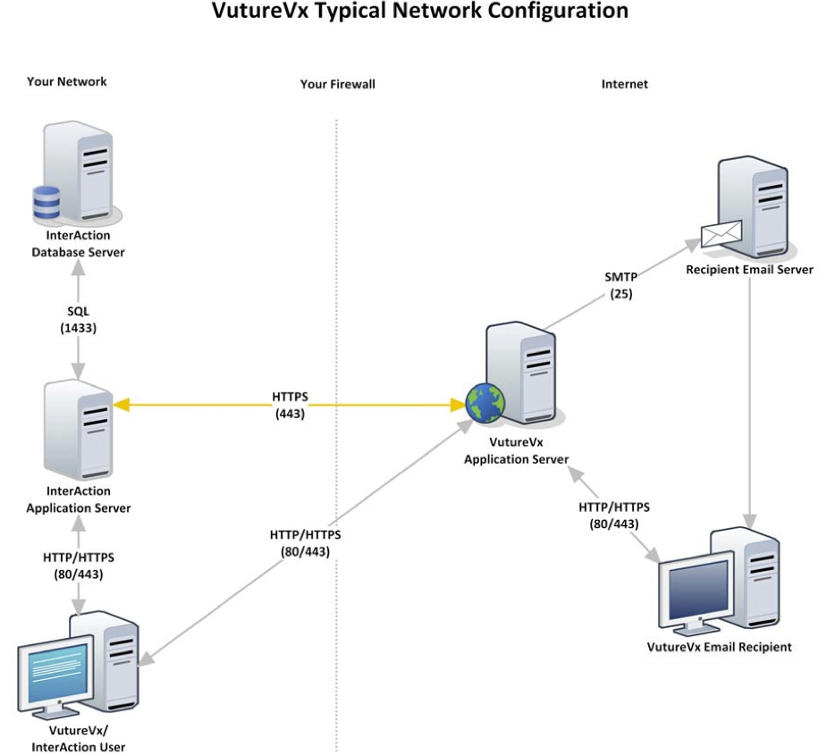

**TYPICAL NEWORK CONFIGURATION |** Example 2

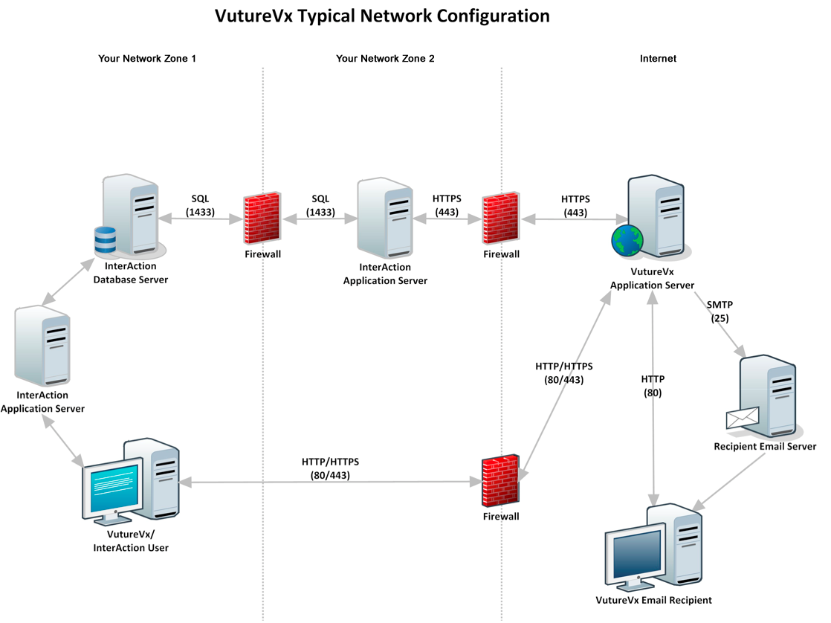

**INTERACTION LOGIN ACCOUNT SET-UP**

**Step 6:** The following information will typically be completed by the **InterAction** **technical contact** in your firm.

The details below are required for Vuture to gain access to your InterAction web client and make the configuration connections. Please set-up and supply the following:

Create a new external/public facing URL that accesses your InterAction web client. This URL cannot be that which users access internally. The URL must be secure with an SSL certificate and usually ends ‘/Interaction’. e.g. https://vuture-clientname.com/interaction  
Details for setting this up can be located in the supplemental instructions at the end of this document. See page 19.

|  |  |
| --- | --- |
|  | INSERT INTERACTION URL |

**Step 7: Create a Vuture InterAction account, with full admin access.** e.g. VutureAdmin

|  |  |
| --- | --- |
|  | INSERT USERNAME |

**The InterAction password**

|  |  |
| --- | --- |
|  | INSERT PASSWORD |

**An IIS username, which must include the Active Directory domain**

Either provide anonymous access to your IIS server, or setup Active Directory authentication and supply the username and password, including the Active Directory domain (e.g. VUTURE\project.manager).

|  |  |
| --- | --- |
|  | INSERT IIS USERNAME |

**An IIS password**

|  |  |
| --- | --- |
|  | INSERT PASSWORD |

**PLEASE NOTE:**

The URL you provide Vuture must be available from the Vuture office and the server we commission them from, and must have a valid SSL certificate. If you provide a username and password, please ensure that NTLM authentication is the primary *Provider* used.

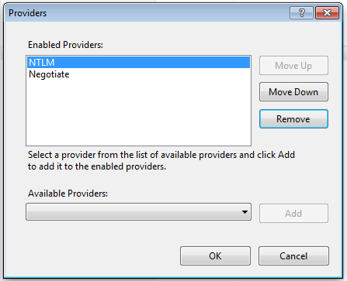

**SETTING-UP ACTIVITY TYPES IN YOUR INTERACTION**

The Vuture platform requires the following activity types be set-up in you InterAction. Please provide the ID’s for the activities you wish to record for the following email activity:

|  |  |  |  |
| --- | --- | --- | --- |
|  | Email Sent |  | 103 |
|  | Email Opened |  | 10068 |
|  | Email Forwarded |  | 10069 |
|  | Email Bounced |  | 10070 |
|  | Email Unsubscribed |  | 10071 |

For Events provide IDs for:

|  |  |  |  |
| --- | --- | --- | --- |
|  | Event: Accepted |  | 104 |
|  | Event: Declined |  | 10012 |
|  | Attended |  | 102 |
|  | Cancelled |  | 10074 |
|  | No Show |  | 10008 |
|  | Walk in |  | 10061 |

For Recording Preference form and Subscription form submissions:

|  |  |  |  |
| --- | --- | --- | --- |
|  | Preference form submitted |  | 10072 |
|  | New contact subscribed |  | 10073 |

Vuture can also record content-specific activities to match your internal BD terms. For example, if you send 'Events’ and 'Briefings’ we will need separate activities set-up for the following:

Please edit the table below depending on your requirements for recording activities

|  |  |  |  |
| --- | --- | --- | --- |
|  | Invitation Sent |  | 101 |
|  | Invitation Opened |  | 10064 |
|  | Invitation Forwarded |  | 10065 |
|  | Invitation Bounced |  | 10066 |
|  | Invitation Unsubscribed |  | 10067 |
|  | [EmailType] Sent |  | [Activity ID] |
|  | [EmailType] Opened |  | [Activity ID] |
|  | [EmailType] Forwarded |  | [Activity ID] |
|  | [EmailType] Bounced |  | [Activity ID] |
|  | [EmailType] Unsubscribed |  | [Activity ID] |
|  | [EmailType] Sent |  | [Activity ID] |
|  | [EmailType] Opened |  | [Activity ID] |
|  | [EmailType] Forwarded |  | [Activity ID] |
|  | [EmailType] Bounced |  | [Activity ID] |
|  | [EmailType] Unsubscribed |  | [Activity ID] |

**PLEASE NOTE:**

When we have access to your InterAction we will be able to get the valid Interaction folder and activity ID's in order to link to your Vx and email templates.

**CREATE INTERACTION TEST LISTS**

In order for us to test the activities getting written please could you set-up two tests lists (With Sponsorship) in InterAction. **Vuture test list 1** and **Vuture test list 2**.

List 2 should have the same Vuture team but should also contain a list of your project team or anyone who will be receiving training.

Vuture Test List 1:

|  |  |  |
| --- | --- | --- |
|  | Lloyd Woodland, Vuture, Project Manager, Lloyd.Woodland@vuturegroup.com |  |
|  | Carolina Diaz, Vuture, Project Manager  Carolina.Diaz@vuturegroup.com |  |
|  | Edd Couchman, Vuture, Vx Manager,  Edd.Couchman@vuturegroup.com |  |
|  | Will Elliott, Vuture, Support Manager,  Will.Elliott@vuturegroup.com |  |
|  | Alex Elliott, PM  Alex.Elliott@vuturegroup.com |  |
|  | Oliver Stuart, Vuture, Project Manager  Oliver.stuart@vutu.re |  |
|  | Vuture Bounce, Vuture, Email bounce test bad@redheat.co.uk |  |
|  | Penny Sargent - Client Services Director  [Penny.Sargent@vutu.re](mailto:Penny.Sargent@vutu.re) |  |

Vuture Test List 2:

|  |  |  |
| --- | --- | --- |
|  | All the above email addresses |  |
|  | Anyone who will be participating in any **TRAINING** sessions |  |

**PREFERENCES FORM**

Since your email recipients will have the ability to update their details and subscription preferences, you will need to supply Vuture with a list of all Marketing lists they have the ability to subscribe to. Against each Marketing list we will need you to provide us with the InterAction folder ID.

**PLEASE NOTE:**

In order to supply Vuture with the correct InterAction folder ID you will need to look in the Folder Access Rights link. This can be found Web Client as IAADMIN and then go to Admin > Access Rights.

Find the long numbers on the left hand side for the correct folder IDs, e.g., 8589934601

|  |  |  |
| --- | --- | --- |
|  | Construction | 394 |
|  | Employment | 384 |
|  | Procurement | 500 |
|  | Technology | 705 |
|  | Companies Act 2014 | 546 |
|  | EU, Competition & Regulated Markets | 757 |
|  | ByrneWallace Legal Updates | 463 |
|  | Banking/Insolvency | 718 |
|  | Tax | 462 |
|  | Financial Services | 760 |
|  | Brexit | 761 |
|  | Property | 762 |
|  | Litigation & Dispute Resolution | 763 |
|  | Health & Social Care | 764 |
|  |  |  |
|  |  |  |
|  |  |  |
|  |  |  |
|  |  |  |
|  |  |  |
|  |  |  |
|  |  |  |
|  |  |  |
|  |  |  |
|  |  |  |
|  |  |  |

**UNSUBSCRIBES AND ANTI-LISTS**

If you require the ability to unsubscribe your clients from specific email lists by types of content e.g. newsletters or Invitations, you will be required to set up anti-lists in your InterAction Marketing list folder as shown below: (Please also provide the IA folder IDs)

|  |  |  |
| --- | --- | --- |
|  | Send No Marketing Communications | 4294957276 |
|  | Send No [EmailType – add your data] | [Folder ID] |
|  | Send No [EmailType – add your data] | [Folder ID] |
|  | Send No [EmailType – add your data] | [Folder ID] |
|  | Send No [EmailType – add your data] | [Folder ID] |

**BOUNCEBACK FOLDER**

Vx requires an anti-list folder to put IA contacts that register a bounceback activity. Before each email send the marketing list is checked against the folder to ensure no contacts in it receive further communications until the email address is corrected or are removed.

|  |  |  |
| --- | --- | --- |
|  | Bounced contacts | 433 |

**NEW CONTACTS**

If you would like all new contacts generated through Vx to be applied to a new Vuture contact folder then please create one in your InterAction and supply the IA folder ID.

|  |  |  |
| --- | --- | --- |
|  | New Vuture Contacts | 765 |

**ADDITIONAL FIELDS**

In order for Vx to register the RSVP (Enumeration) activity we require the additional field to be called RSVP or at least have RSVP in the name. On some systems these are known as Response or Attendance but RSVP is what is required for Vx. We also ask that the options within these fields be named like either of the following: Yes, Accept, Accepted, No, Decline, Declined.

|  |  |
| --- | --- |
|  | Are your RSVP fields named correctly? Yes |

**Multivalue Field**

Please also add a multivalue additional field to ‘**Vuture Test List 2**’ as this is required during training. Please choose **one** of the following:

1. ‘Dietary Requirements’ as a multivalue field, with a few list items such as No Fish, Allergic to Nuts, Vegetarian, Kosher or as you see fit.

2. ‘Workshop Choice’ as a multivalue field, with list items of Workshop 1, Workshop 2, etc.

|  |  |
| --- | --- |
|  | Multivalue field created in InterAction on Vuture Test List 2? Yes |

**RETURNED RESULT THRESHOLD FROM IA TO VX**

A standard setting in your InterAction is to pass a maximum of 10000 contacts to the Vx platform at any one time. This can cause issues when marketing and suppression lists container more than 10000 contacts.

To increase the returned results you should set your IA maxbresultthreshold and maxresultcountceiling to 50000 or the number of contacts in your largest marketing list.

These settings are editable in in the interaction.cfg file on the interaction application server.

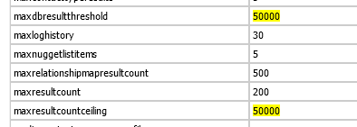

|  |  |
| --- | --- |
|  | Threshold increased? |

**Increasing the 10,000 result limit**  There are three settings in the InterAction.cfg file that need to be changed in order to ensure InterAction does not limit the records that are returned to Vuture.

 1. **maxResultCountCeiling**: This is the absolute maximum number of records returned. This default is 10,000 but we recommend this is increased to 50,000 or the size of your anticipated largest list size.

2. **maxDBResultThreshold**: This is the maximum number of records returned from the database for memory intensive requests. The default is 10,000 but we recommend this is increased to 50,000 or the size of your anticipated largest list size.

3. **inClauseThreshold**: The number of items (e.g. contacts) used in the where clause before switching to a temp table join. The default is 100 but we recommend this be increased to 500.

**EVENT MODULE SET-UP**

The following information is required to configure the event module in your Vuture platform.

**ADDITIONAL FIELDS**

In order for Vuture to record the Event Attendance activities, we require an additional field to be created in event folders called **Attendance** with the following list options: ***Attended, Declined, Walk-in, No Show, Cancelled***

Action: Set-up the Attendance additional field in the Vuture test lists **1 & 2**

|  |  |
| --- | --- |
|  | Is the Attendance Additional field set-up with list options in the Vuture test list 1 and Vuture test list 2 folders? Yes |

**EVENT CONFIGURATION OPTIONS**

**Notification Email Address:**

|  |  |
| --- | --- |
|  | events@byrnewallace.com |

The from email address for the email sent when a client arrives **Default: events@vuturevx.com**

**Notification Email Name:**

|  |  |
| --- | --- |
|  | ByrneWallace Events |

The from email name for the email sent when a client arrives - **Default: VutureVx Events**

**Attended Activity Type Id:**

|  |  |
| --- | --- |
|  | 102 |

InterAction activity type id for event attended: **InterAction1 - Default: 102**

**Primary Sponsor Field Id:**

|  |  |
| --- | --- |
|  | 4294967295 |

InterAction additional field id for primary sponsor:  **InterAction1 - Default: 4294967295**

**Accepted Activity Type Id:**

|  |  |
| --- | --- |
|  | 104 |

**Declined Activity Type Id:**

|  |  |
| --- | --- |
|  | 10012 |

**Walk in Activity Type Id:**

|  |  |
| --- | --- |
|  | 10061 |

**No Show Activity Type Id:**

|  |  |
| --- | --- |
|  | 10008 |

**Cancelled Event Activity Type Id:**

|  |  |
| --- | --- |
|  | 10012 |

**BADGE TEMPLATES (IF REQUIRED)**

Please provide a sample of your badge templates if you have any. 

|  |  |
| --- | --- |
|  | [AVERY TEMPLATE PROVIDED?] |

Badge template size? E.g. Avery: 5390

|  |  |
| --- | --- |
|  | [AVERY TEMPLATE SIZE?] |

To brand the Event App provide a high res logo at 210px or 420px wide.  
Set the Event App banner colour in hex colour format. The default is #FFFFFF which is white.  
In order to generate an iOS app logo upload a logo at 196px square in PNG format.

**Logo**

|  |  |
| --- | --- |
|  | [DID YOU PROVIDE VUTURE WITH LOGO 210PX OR 420PX?] Yes |

**IOS App Logo**

|  |  |
| --- | --- |
|  | [DID YOU PROVIDE VUTURE WITH LOGO 196 SQUARE?] Yes |

**Hex Code – App banner**

|  |  |
| --- | --- |
|  | #EEEEEE |

**SUPPLEMENTAL INSTRUCTIONS:  
Connect Vx To Your InterAction Application Server**

1. Create a URL with an A record that points at the external interface of your InterAction Application Server

* This will be used by Vx to connect to the InterAction Web Client
* Register or create sub-domain such as interaction.mycompany.com
* Create an A record for this domain, with your external DNS provider, that points at the external IP address that will route through to your InterAction Application Server
* You can check this record by using an online DNS lookup tool such as <http://www.mxtoolbox.com/DNSLookup.aspx>
* Bear in mind that new A records can take 24-48 hours to propagate across the internet

1. Create a route on your firewall to forward HTTPS traffic from Vx to your InterAction Application Server

* You will be provided with the public IP address or address range of your Vx instance provided by Vuture
* Create a route on your firewall to allow traffic from this IP address (or range) on port 443 only to forward to your InterAction application server

1. Set up an HTTPS certificate and the bindings on IIS for the URL created in step 1

* Obtain an external SSL certificate for the URL that you created in step 1 making sure the Fully Qualified Domain Name (FQDN) of the certificate exactly matches the registered URL
* We suggest that you obtain a certificate with 256-bit encryption
* If you created a subdomain then you can use a wildcard SSL certificate
* For a step by step guide to creating a certificate signing request and installing an SSL certificate on IIS7 see <http://www.sslshopper.com/article-installing-an-ssl-certificate-in-windows-server-2008-iis-7.0.html>
* Add secure bindings for the URL to the IIS site of the InterAction Web Client
* [*RECOMMENDED: add authentication to the IIS site. If this is already enabled or if you add IIS authentication then please create a username and password for Vx to use.*](http://nautadutilh.vuturevx.com/support/main-menu/integrations/interaction/setup-iis-authentication.aspx)

4. Please provide Vuture with the following so we can test the set-up

* InterAction secure URL created, e.g. https: //interaction.mycompany.com
* Username and password for an InterAction account that will be used by Vx has permissions to retrieve lists and write activities. See separate InterAction user permissions document for more details on required permissions.
* If IIS has authentication enabled then we require a username and password we can use to authenticate.

**Setup IIS Authentication**

We recommend that you setup IIS authentication to add an extra layer of security when connecting to the web client.

Below is a general guide on how to setup IIS authentication. Note this may need to be tailored for your specific environment.

**Create a Windows account that will be used to grant access to InterAction**

Create a new Windows account that you want to use to grant Vuture access to InterAction (or choose an existing account).

**Enable Windows Authentication for this account**

Enable Windows Authentication on the Default website and disable Anonymous Authentication.

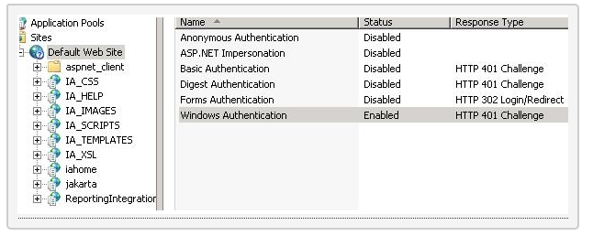

**Create an Allow Rule in  Authorization Rules for the chosen Windows account**

Click on Authorization Rules for the default website and add an Allow Rule for your chosen Windows account.

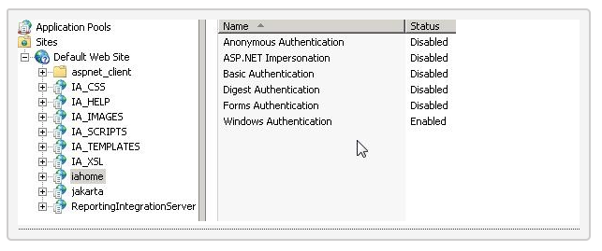

**Check that Authorization rules are being inherited**

Check that the Interaction Applications, particularly iahome, have inherited the authorization rule. If not then set them manually.

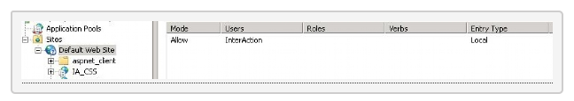

**InterAction URLs and Passwords**

**URLs and password**

There are five things we need from each client in order to connect:

1. The URL to their Interaction (these usually end with ‘/Interaction’)
2. The Interaction username, with Admin access
3. The Interaction password
4. An IIS username, which must include the Active Directory domain
5. An IIS password

The IIS information can be blank, and so can the Interaction password. The URL they give us must be available from our office and the server we commission them from, and must have a valid SSL certificate.  
The client’s firewall must be set up to forward (NAT) connections from our IP addresses on port 443 to their Interaction web server.

**Testing URLs**

There are a number of methods for testing the URL and passwords we have been given are valid. The simplest is to open Internet Explorer (Interaction only works in IE) and try to visit the URL the client gave us. We should see the login screen if all is working correctly.

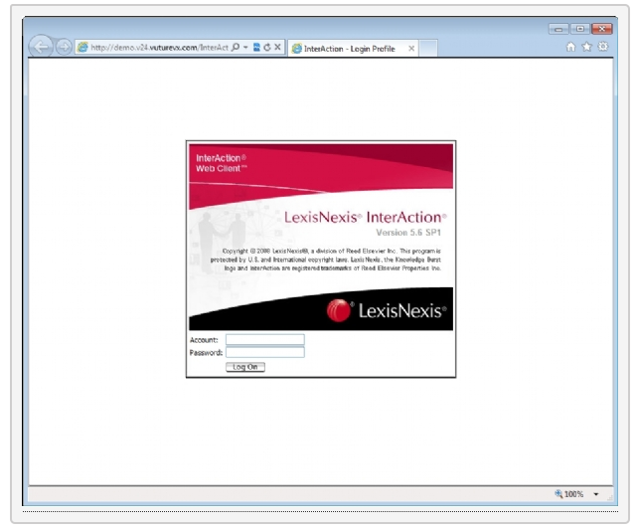

**InterAction Vx Account Permissions**

**InterAction Vx Account**

Vx uses a single InterAction account to connect and make the various API calls required by the integration.

Each Vx user can be set up to use his or her own InterAction account, which should have the Vx InterAction account added as a proxy through InterAction.

**Required Permissions**

The Vx InterAction account requires the following permissions:

|  |  |
| --- | --- |
| **Access Rights for Folders** | |
| These rights should be set for all folders that are to be made available in Vx. | |
| **Access Right** | **What it Allows** |
| Read | Allow you to see contacts contained in the folder. Also allow you to see any folder-specific information for the folder, such as additional field values. |
| Add Contacts | Allow you to create a contact **sourced** in this folder. |
| Delete Contacts | Allow you to delete a contact from this folder (if the folder sources the contact) or remove a contact from this folder (if the contact is linked into the folder). |
| Link Contacts FROM this Folder | Allows you to link a contact that is sourced in this folder **into** another folder. |
| Link Contacts INTO this Folder | Allows you to link a contact that is sourced in another folder into this folder. |
| **Contact Data** | |
| Add | Add all types of folder-specific data to contacts:   * Addresses, phones, and e-addresses * Related contacts * Activities * Classifications |
| Edit | Edit all types of folder-specific contact data:   * Name * Company Association * Addresses, phones, and e-addresses * Related contacts * Notes * Additional fields * Activities |
| Delete | Delete all types of data to contacts:   * Addresses, phones, and e-addresses * Related contacts * Activities * Classifications |

**Managing Unsubscribes Using InterAction**

This explains how Vx deals with the process of managing unsubscribe within InterAction CRM and then methodology for minimising manual data management.

**Managing the unsubscribe process**

By default InterAction has a folder called **\* Send no marketing communications** - whilst this list is useful for managing clients that do not wish to receive *any* marketing communications most firms require a more sophisticated opt-out process.

While we are able to adapt to an unsubscribe process which matches the firms requirements, we typically encourage clients to automate 3 types of unsubscribes:

* Unsubscribes from **types** of communications
* Unsubscribes from a **specific** list
* Unsubscribes from **all** communications

**Unsubscribes from types of communications**

Most emails can be categorised by type (e.g. Newsletters, Invitations etc.). In order to allow users to opt out of this type of mailing we set up folders, which correspond with the mailing type.  Typically this will be in the format  **\* Send no event invitations**.

If a recipient clicks on the opt-out form they are able to choose from a check box list which type of mailing they no longer wish to receive. They may also choose to be added to a list, which will write them into a corresponding list in InterAction. VutureVx will automatically add or remove the recipient from the appropriate folder in IA.

**Unsubscribes from specific lists**

Some recipients may wish to remain on a type of communication (for instance events) but wish to be removed from a list specific mailing (for instance golf events). With every mailing the firm may therefore offer the option of not receiving any more communications from that particular list.

In InterAction the process would be to set up a corresponding anti-list that must be named in the format **Anti - name_of_list** *–* if the recipient chooses to opt-out of that list they will be automatically added to the corresponding folder.

**Unsubscribes from all communications**

If a recipient chooses to be removed from all communications they will be added to the **\* Send no marketing communications** folder.

**Sending the mail**

At the point of sending the mail, a VutureVx user will be prompted to select the type of mailing they are sending and which list they are sending from.

VutureVx will automatically pull in the list directly from InterAction. When the send button is hit, the system will automatically check the 3 corresponding unsubscribe folders: *Send no mails; Send no type of mails and the list specific unsubscribe folder.* Opted-out users from any of these corresponding lists will automatically be excluded from the mailing.

**VUTURE ASIA PAC**

Circular Quay  
Level 34, 50 Bridge Street  
Sydney 2000  
Australia  
**T:** +61 (0) 2 8216 0767 **E: info@vuturegroup.com**

**VUTURE NORTH AMERICA**

902 Broadway  
7th Floor, Suite 11  
New York, NY 10010  
USA  
**T:** +1 646 378 2137  
**E: info@vuturegroup.com**

**VUTURE EUROPE**

5–13 Great Suffolk Street  
London  
SE1 0NS  
**T:** +44 (0)20 7928 6250  
**E: info@vuturegroup.com**

www.vuturegroup.com