

Manager of the Trainee programme, Byrne Wallace, 88 Harcourt Street, Dublin 2. 07/February/2019

Dear sir/madame,

I am a third-year business and law student at University College Dublin and am writing to you to apply for the position of intern at your Dublin offices for summer 2019. I became aware of the opportunity through a careers fair at my university.

Since starting my degree in business and law, a career in corporate law has become an obvious choice for me, standing at the intersection of two of my interests and chosen fields of study. My decision to apply for Byrne Wallace was principally influenced by the firm’s award-winning reputation, both domestically and internationally. The firm’s business expertise was particularly attractive, as was an opportunity to work with businesses and organizations at the forefront of global and Irish business, banking and finance.

My varied background has provided me with many skills that I hope your firm will find useful. My time spent at university has allowed me to develop a wide variety of skills applicable to a career in law. These include most notably an ability to analyse information with significant attention to detail while maintaining a view of the bigger picture, legal research skills, and logical reasoning capabilities. My ability to employ these skills have manifested themselves in my academic performance, which currently a 1.1 and puts me on track to graduate with a first-class honour’s degree.

I have heard through previous summer interns, of the emphasis placed on teamwork within Byrne Wallace. My involvement with teams through sport over the years has equipped me with extensive teamwork skills and has taught me what it takes to excel both collectively as a team and individually.

Aside from my degree, I have pursued my interests in the commercial world in the form of two online business ventures during my second year of college. Being exposed to the realities of the business world taught me the importance of creating and sustaining a competitive edge, something I believe I can put into practice when dealing with the clients of Byrne Wallace.

Thank you for the time taken to consider my application. I would welcome an opportunity to discuss my background and suitability to your firm in greater detail and am available for an interview at any time.

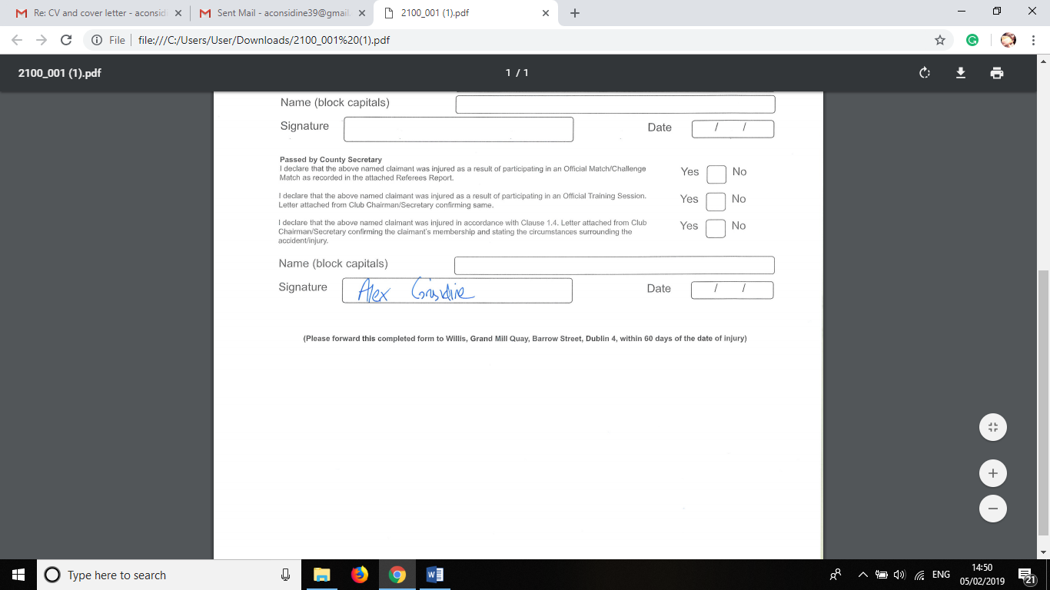Yours sincerely,