Ardit Hoxha

26 Cedar Avenue,

Ridgewood,

Swords,

Co. Dublin,

Ireland

0871508190

Ms. Beth Onslow

HR Administrator

ByrneWallace

88 Harcourt Street,

Dublin 2

06 February 2017

**Summer Internship Programme 2017**

Dear Ms. Onslow,

Having come across the advertisement of the position made available by ByrneWallace, I was encouraged to apply as I believe that I have the necessary skills that your firm seeks in their employees. I am currently a Masters of Law Student at Dublin City University, having graduated with a Bachelor of Civil Law from Dublin City University in May of 2016.

While at university it became clear to me, my desire to associate my career in legal practice. This desire spurred me on to apply and complete an internship at Brophy Solicitors where I was afforded the opportunity to work with the Immigration Law team. Here I developed a keen interest in commercial law through engagement with colleagues at the time within the firm.

I built on that experience by applying to Ireland’s largest market capitalised cooperation, CRH Plc, as a Regulatory, Compliance & Ethics Intern. This was a significant step up to my previous internships and work experiences as I was working with bigger projects and I took on more responsibility as I was reporting to senior competition law lawyers from CRH and dealing directly with Senior Partner’s of various international law firms. I relished this opportunity to challenge and improve myself personally and professionally with skills such as negotiation, leadership alongside project management and research skills which would bring great value to ByrneWallace.

I gained an enhanced understanding into what makes a standout ByrneWallace employee by researching current ByrneWallace employees LinkedIn profiles and engaging with the content made available on your website. From this I have tried to tailor my experience to match the desired skillset of ByrneWallace: legal knowledge, experience in a professional legal environment and a problem solving attitude.

Outside of my studies I enjoy keeping up to date with legal developments, reading and researching articles on international legal databases and by being a subscriber to the monthly issue of the Law Society of Ireland Gazette. I am also a frequent visitor of the ByrneWallace homepage where current partener’s and trainees publish interesting articles and legal reading content on current affairs in the legal industry.

I am confident that my academic achievements and work experiences in my career to date make me a strong candidate for this position. I would welcome the opportunity to meet with you and am available for interview at any time. You may contact me by phone or email with my contact details found on my application form, CV and cover letter.

Thank you for your time and consideration of my application. I look forward to hearing from you in the near future.

Yours Sincerely,

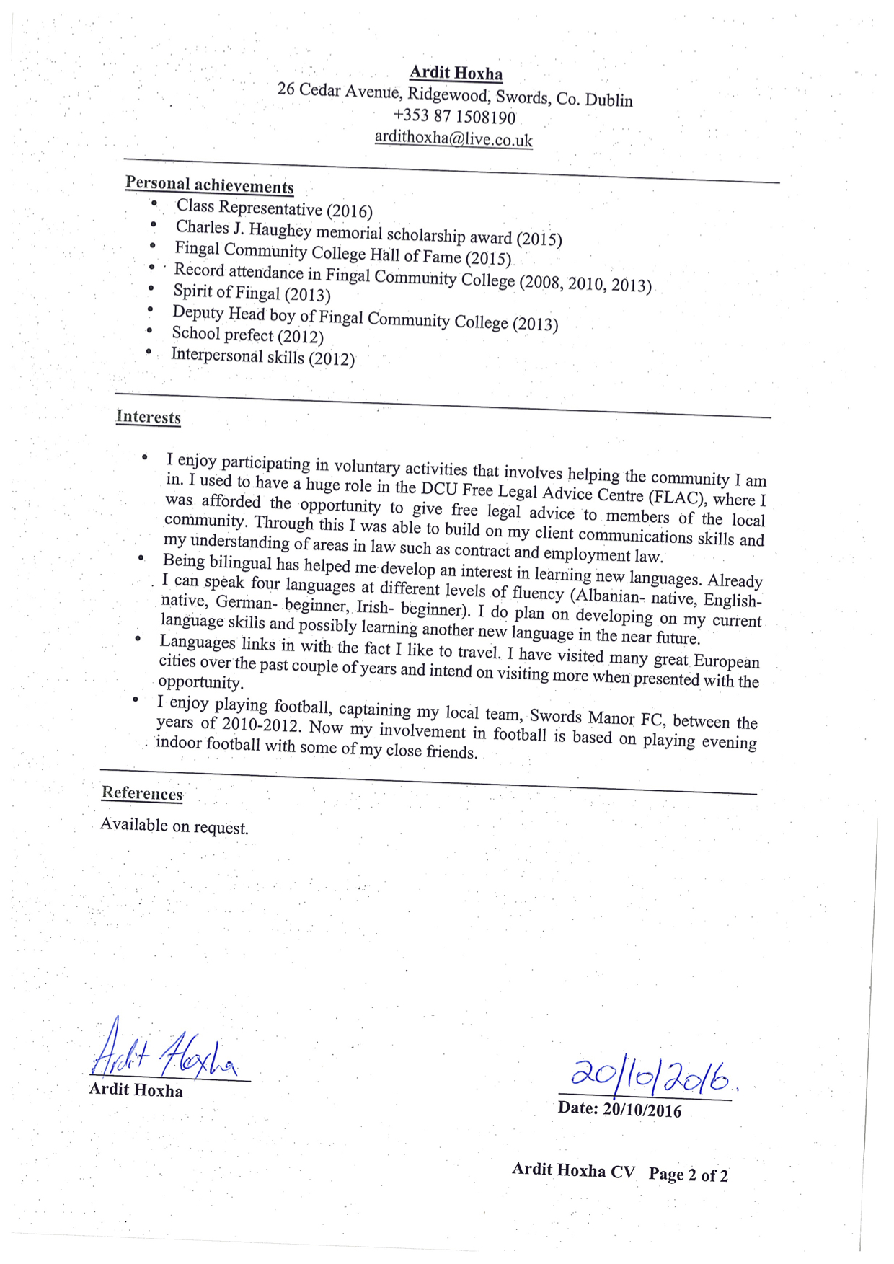

…………..

**Ardit Hoxha**