John Grogan

Attymass House

Attymass

Ballina

Co. Mayo

` F26 C2N4

Dear Ms Onslow,

I am writing to apply for a summer internship position at Byrne Wallace as advertised on your website. I am currently in my final year of a Bachelor of Civil Law degree at the National University of Ireland Galway (NUIG).

I am currently working as an intern for two days a week in the Competition and Consumer Protection Commission (CCPC). From this placement I have come to appreciate the importance of equal opportunity in commerce for smaller enterprises as well as ensuring competitive practices to benefit the consumer. I can contrast this with my voluntary work with the NUIG Free Legal Advice Clinics (FLAC). FLAC is a non-profit NGO which provides legal advice to people who seek such help but may not be able to afford it. Whilst this work focuses more on client interaction, it can be quite testing due to the vast range of problems which clients present with. This position requires interpersonal skills and greater adaptability in order to advise on a broad range of issues. I have determined from my attendance of the A&L Goodbody Law Start Day that a career in corporate law is the path which best suites me and to that end I am now seeking further experience in this environment.

I am applying to Byrne Wallace as the firm’s values closely reflect my own. The promotion of hard work, along with strong interpersonal connections and knowledge is something I strive for. The client focused approach of the firm and the importance of the firm’s reputation is something I treat with paramount importance. Wining the client service award and being the first in Ireland to secure the Lexel quality mark and becoming ISO certified is a testament to how seriously the firm treats customer relations. Furthermore, the high calibre clientele that the firm attracts across a diverse range of sectors demonstrates great ambition. I am particularly interested in the firm’s success in the construction and environmental sectors.

My ability to work well with and to understand the needs of a client have been refined by working with FLAC and in other work placements. I am an independent, critical thinker who has a pragmatic approach to resolving issues. This is best exemplified in a business context by winning the AIB Senior Business Student award in Leaving Certificate as well as being specifically requested to recruit and lead a team to submit my taxation paper to the Irish Taxation Institute. Also as Treasurer of FLAC I have developed a keen commercial awareness particularly in a global context through 2017 and 2018.

Thank you for taking the time to review my application, please contact me as per the information below if you would like to arrange an interview. I hope you find the candidates that best suit your firm.

Yours sincerely,

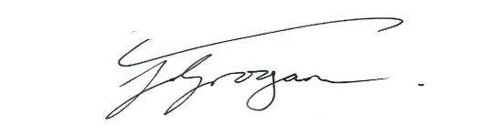

_________________________________

John Grogan

Email: j.groganwork@gmail.com Telephone: 087-6118477