Molly Kearns
08/10/2021

Emily Murray,
Human Resource Generalist,
88 Harcourt Street,
Dublin 2,
D02 DK18,
Ireland

Dear Emily Murray and the ByrneWallace Recruitment Team,

I am currently in my final year of a Business and Law Degree in University College Dublin, and I am on track to achieve a First-Class Honours, Grade 1. I believe that I am an excellent candidate for this position. I have a wide variety of experience in customer service roles, which have allowed me to develop interpersonal, organisation and communication skills. I have previously worked in an administrative role in a statutory regulator and am currently volunteering with the UCD Student Legal Service.

I am very interested in beginning my career in ByrneWallace. As an undergraduate who is unsure of exactly which area of law I want to specialise in, I find ByrneWallace’s broad variety of practice areas incredibly appealing. I also admire ByrneWallace’s pro bono work, as well as your commitment to the promotion of children’s education and well-being, which is something I have devoted some time to as an active member of my local GAA club.

I am very enthusiastic about this opportunity and will be delighted to meet for an interview. I can be reached on +353 (87) 610 9997, or at molly.nicheirin@ucdconnect.ie.

Thank you for your time and consideration. I look forward to hearing from you.

Yours sincerely
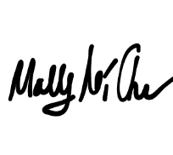
Molly Kearns

