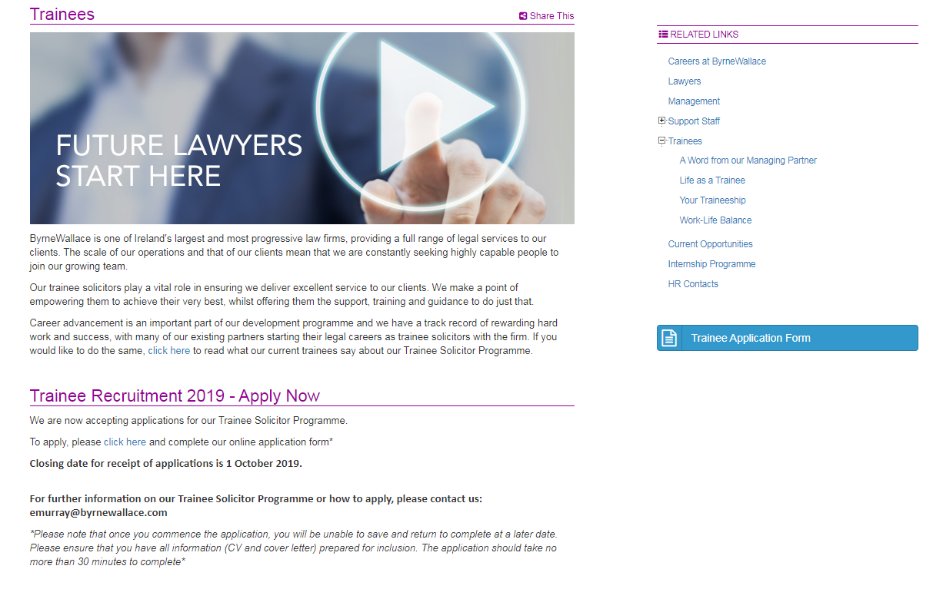

Top of Form

Trainee Recruitment 2023 - Apply Now

Bottom of Form

We are now accepting applications for our Trainee Solicitor Programme.

To apply, please [click here](https://byrnewallace.com/careers/current-opportunities/application-form.html) and complete our online application form*

**Closing date for receipt of applications is 9 October 2023.**

**For further information on our Trainee Solicitor Programme or how to apply, please contact us: recruitment@byrnewallace.com**

*\*Please note that once you commence the application, you will be unable to save and return to complete at a later date. Please ensure that you have all information (CV and cover letter) prepared for inclusion. The application should take no more than 40 minutes to complete\**

LINK TO TRAINEE FORM: <https://byrnewallace.com/careers/current-opportunities/application-form.html>